DIS-L-S-Winter Count-Lone Dog-Atlantika

# The Atlantika Winter Count by Lone Dog, a Yanktonai Lakota

“Winter Count” is the imprecise English translation of the Lakota *Waniyetu* ***wowapi*.**  *Waniyetu* refers to the Lakota custom of measuring a year from the first snowfall to first snowfall and ***wowap*i** refers to “that which can be read or counted.” In practice, *Waniyetu* ***wowapi*** was a record of the most memorable, notable or unusual events identified by a pictograph drawn by a Keeper who was empowered as the oral historian for a Lakota community (***tiyospaye***). Originally, these pictographs were painted on buffalo hide and deer skin and in the reservation period on muslin, white cloth or canvas and even paper. The *Waniyetu* ***wowapi*** pictographs were arranged chronologically in a spiral when these were composed on hide or skin, and when they were composed on cloth and paper they could be arranged in columns. These pictographs, therefore, do not constitute a history but act as a mnemonic device to open a window on that year and its events.

The Keeper was also responsible for retelling the ***tiyospaye’s*** history at various times throughout the year. During ceremonies or other social gatherings, he would bring out the count and use it as a visual reference to name the years. In this way, the members of the band knew their history and could use particular years to recall events in their own lives, such as the year of someone’s birth. It was important that the Keeper, in consulting with the community elder’s, chose events that were easily remembered by the entire tribe.

When the Keeper could no longer fulfill his role as historian, the duty was passed on to another male member of the **tiyospaye**—usually a son or nephew—whose first obligation was to copy his predecessor’s Winter Count. With the arrival of the Euro-Americans which brought devastating change for the western tribes Keepers began to add written captions to their pictograph images. By the end of the 19th century, some Winter Counts were only written texts. Eventually pictographs were replaced by written year-names as the device to record community history.

The Lakota winter counts are named after their keepers, the person who collected

them, or a place. They cover periods of time spanning from 1700 to 1919, and are known as:

American Horse (keeper)

Long Soldier (keeper)

Battiste Good (keeper)

Major Bush (collector)

Cloud Shield (keeper)

No Ears (keeper)

The Flame (keeper)

Rosebud (location)

Lone Dog (keeper)

The Swan (keeper)

Over 170 Lakota winter counts are extant. Many are exact replicas or modified versions of an original copy if known or they can be grouped into specific traditions. Lone Dog, The Flame, The Swan, Long Soldier and the Major Bush winter counts were all collected from tiospayes of northern Lakotas, while American Horse, Battiste Good, Cloud Shield, No Ears and Rosebud winter counts are from the southern Lakota bands.

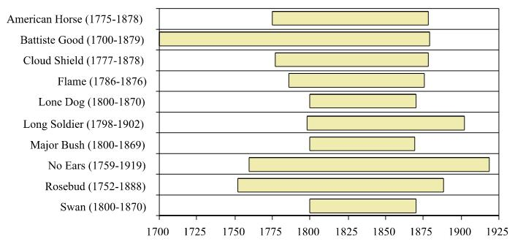

The chronological periods that each of the major winter counts cover.

## History of the Lone Dog Winter Count

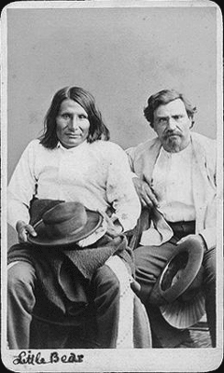Lone Dog (*Shuuka-ishnala*), was a Yanktonai Lakota living ca.

1870 near where Fort Peck would later be established. The Yanktonai (ihanke ‘end,’ tonwan ‘village,’ na diminutive: ‘little-end village.’Riggs) are one of the seven divisions or sub-tribes of the Dakota, speaking the same dialect as the Yankton and believed to be the elder tribe Long (1823). The first reference to the Yankton is by La Sueur in 1700. Lewis and Clark in 1804 reveal that the Yanktonai had traversed the headwaters of the Sioux, James, and Red rivers on a migration from their eastern origin, north of Mille Lacs, Minnesota, probably at the beginning of the 18th century. It is likely that they followed or accompanied the Teton, while the Yankton turned more and more toward the southwest. Long (1823) speaks of Yantonai as one of the most important of the Dakota tribes, their hunting grounds extending from Red river to the Missouri. Warren (1855) gives as their habitat the country between the James and the Missouri Rivers, extending as far north as Devils Lake, and states that they fought against the United States in the War of 1812, and that their chief at that time went to England. It does not appear that this tribe took any part in the Minnesota massacre of 1862.

In 1865 separate treaties of peace were made with the United States by the Upper and Lower Yanktonai, binding them to use their influence and power to prevent hostilities not only against citizens, but also between the Indian tribes in the region occupied or frequented by them. Subsequently they were gathered on reservations, the Upper Yanktonai mostly at Standing Rock, partly also at Devils Lake, North Dakota; the Lower Yanktonai (Hunkpatina) chiefly on Crow Creek Reservation, South Dakota, but part at Standing Rock Reservation, North Dakota, and some at Fort Peck Reservation, Montana, where Lone Dog was re-located.

**Bazille Jacque Marie "Basil" Clément (1824-1910) with Martin Charger (1833-1900) [not “Little Bear”], Sans Arc.** stereograph ca. 1870-1875, taken by J. Gurney & Son, New York.

Yanktonai customs and characteristics are those common to the Dakota. Long (1823) states that they had no fixed residence, but dwelt in fine lodges of well dressed and decorated skins, and frequented, for the purpose of trade, Lake Traverse, Big Stone Lake, and Cheyenne River. Their chief, Wanotan, wore a splendid cloak of buffalo skins, dressed so as to be a fine white color, which was decorated with tufts of owl feathers and others of various hues. His necklace was formed of about 60 claws of the grizzly bear, and his leggings, jacket, and moccasins were of white skins profusely decorated with human hair, the moccasins being variegated with plumage from several birds. In his hair, secured by a strip of red cloth, he wore 9 sticks, neatly cut and smoothed and painted with vermilion, which designated the number of gunshot wounds he had received. His hair was plaited in two tresses, which hung forward; his face was painted with vermilion, and in his hand he carried a large fan of turkey feathers.

The primary divisions of the tribe are Upper Yanktonai and Hunkpatina. These are really sub-tribes, each having its organization. The first notice of subdivisions is that by Lewis and Clark, who mention the Kiyuksa, Wazikute, Hunkpatina, and the unidentified Hahatonwanna, Honetaparteenwaz, and Zaartar. Hayden (1862) mentions the Hunkpatina, Pabaksa, and Wazikute, and speaks of two other bands, one called the Santee, and probably not Yanktonai. J. O. Dorsey gives as subdivisions, which he calls gentes, of the Upper Yanktonai: Wazikute, Takini, Shikshichena, Bakihon, Kiyuksa, Pabaksa, and another whose name was not ascertained. His subdivisions of the Hunkpatina are Putetemini, Shungikcheka, Takhuhayuta, Sanona, Ihasha, Iteghu, and Pteyuteshni. English translations of names of hands of Yanktonai of which little else is known are `The band that wishes the life’ and The few that lived.’

The population as given at different dates varies widely. Lewis and Clark (1806) estimate the men at 500, equal to a total of about 1,750; Long (1823), 5,200; Report of. Indian Affairs for 1842, 6,000; Warren in 1856, 6,400; in 1867, 4,500; ; Report of. Indian Affairs for 1874,2,266; in 1885 returns from the agencies gave 6,618, while in 1886 the reported number was only 5,109. The Lower Yanktonai, or Hunkpatina, are chiefly under the Crow Creek school, South Dakota, where, together with some Lower Brules, Miniconjou, and Two Kettles, they numbered 1,019 in 1909. There are others under the Standing Rock agency, North Dakota, but their number is not separately enumerated. The Upper Yanktonai are chiefly under the Standing Rock agency, and while their number is not separately reported, there are probably about 3,500 at this place. The Pabaksa branch of the Upper Yanktonai are under the Ft Totten School, North Dakota, but their number is not known. The so-called “Yankton Sioux” under the Ft Peck agency, Mont., are in reality chiefly Yanktonai.. These, with several other Sioux tribes, numbered 1,082 in 1909.

Basil Clément was a trader of French extraction who passed himself off as a mixed-blood -- through his wife who was a daughter of Peter Sarpy, a Mexican-Indian mixed-blood fur trader at the American Fur Company branch post at Rapid Creek, Dakota Territory (Deland 1922: 282-3). Clément developed trade with the Infantry and the Indians at Little Bend near Ft. Sully and learned Lakota. In his dealings with Anglo-whites who could not pronounce his French name correctly they shortened it to “Clemo” and finally to “Claymore” by which surname he was popularly known to the U.S. military authorities.

In 1870, on one of his trading expeditions to Montana Clément met Lone Dog (*Shuuka-ishnala*), a Yanktonai Lakota living near where Fort Peck would later be established.

It was very unusual for a Keeper of a Winter Count to sell his own original, but Clément was probably so interested in it for himself that Lone Dog finally relented and sold it to him. bought his Winter Count. Clément acquired Lone Dog’s own descriptions of the meaning of the pictographs of his Winter Count and made translations of them.

S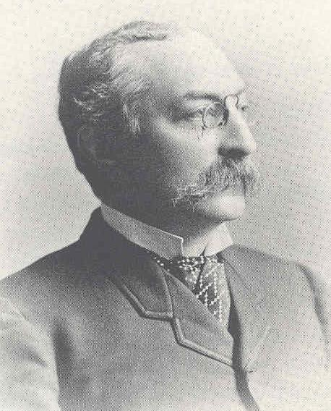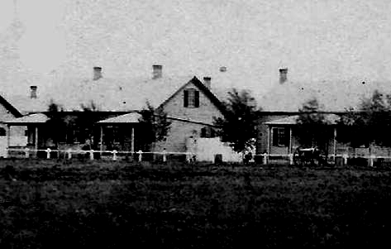econd Lieut. Hugh T. Reed, First United States In­fantry, who was stationed at the Brule Agency, not far from Ft. Sully (Smith 1915:1076), heard of Clément’s copy of Lone Dog’s Winter Count and contacted him at Ft. Sully. Clément graciously allowed him to copy it on a strip of cotton cloth, one-yard square. It is also possible that Reed was able to copy Clément’s transcriptions of the meanings of the pictographs as well. The original Lone Dog Winter Count and Clément’s transcriptions have never been located. Clément died in December 1910 in Ziebach County, South Dakota and was buried in the Mossman Cemetery, at Ridgeview, Dewey County, South Dakota (Penticoff 2011), but the disposition of his possessions remains unknown.

Garrick Mallery (1831-1894)

Fort Sully, officers’ quarters, 1875, where Col. Mallery met Lt. Reed and borrowed his copy of Lone Dog’s Winter Count where he photographed it (Carson 2015).

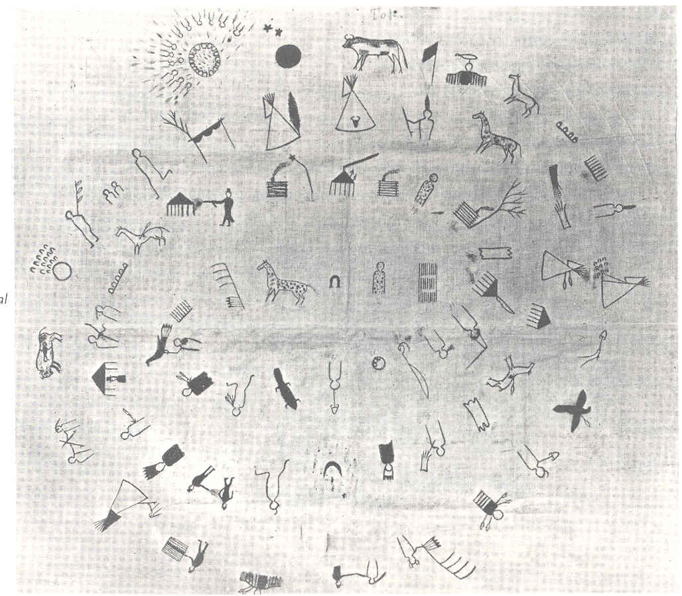

While visiting Ft. Sully, Second Lt. Reed met Capt. Garrick Mallery, in the U. S. Infantry Signal Corps. who was stationed at Ft. Sully. Mallery was then developing an interest in Native American sign language, petroglyphs and pictographs. Reed related his story of having copied Clément’s copy of Lone Dog’s Winter Count and Mallery was fascinated. He borrowed Reed’s copy and photographed it. He published a lithograph of this photograph in 1877 through the U. S. Geological and Geographical Survey of the Territories under the editorship of geologist Ferdinand Vandeveer Hayden (1829-1887.

Lithograph of Mallery’s photograph of Reed’s copy of Lone Dog’s Winter count (Mallery 1877).

In that 1877 document Mallery explained the research he had undertaken to verify the authenticity of Cléments transcriptions and the cultural context and contents of each of the “year totems” that had been painted on Lone Dog’s Winter Count. Mallery republished this description of his research methodology later after James Wesley Powell hired him as an ethnologist to work for the Bureau of American Ethnology. In the fourth volume of the Bureau of American Ethnology Mallery (1886) noted that Clément

“obtained informa­tion concerning the chart from personal inquiries of many Indians, and whose dictated translation of them, reduced to writing in his own words, forms the basis of that given in the present paper. The genu­ineness of the document was verified by separate examination, through another interpreter, of the most intelligent Indians accessible at Fort Rice, and at a considerable distance from Clément, who could have had no recent communication with those so examined. One of the latter, named Good-Wood, a Blackfoot Dakota and an enlisted scout attached to the garrison at Fort Rice, immediately recognized the copy now in possession of the writer as "the same thing Lone-Dog had," and also stated that he had seen another copy at Standing Rock Agency in the hands of Blue-Thunder, a Blackfoot Dakota. He said it showed “some­thing put down for every year about their nation.” He knew how to use it as a calendar, beginning from the center and counting from right to left, and was familiar with the meaning of many of the later charac­ters and the events they commemorated, by which he corroborated Clément's translation, but explained that he had forgotten the interpre­tation of some of the earlier signs, which were about those things done before his birth. All the investigations that could be made elicited the following ac­count, which, whether accurate or not, the Indians examined certainly believed: Probably with the counsel of the old men and authorities of his tribe, Lone-Dog ever since his youth has been in the habit of de­ciding upon some event or circumstance which should distinguish each year as it passed, and when such decision was made he marked what was considered to be its appropriate symbol or device upon a buffalo robe kept for the purpose. The robe was at convenient times exhibited to other Indians of the nation, who were thus taught the meaning and use of the signs as designating the several years, in order that at the death of the recorder the knowledge might not be lost. A similar motive as to the preservation of the record led to its duplication in 1870 or 1871, so that Clement obtained it in a form ending at that time. It was also reported by several Indians that other copies of the chart in its various past stages of formation had been known to exist among the several tribes, being probably kept for reference, Lone-Dog and his robe being so fre­quently inaccessible.

Present knowledge of the Winter Count systems renders it improba­ble that Lone-Dog was their inventor or originator. They were evi­dently started, at the latest, before the present generation, and have been kept up by a number of independent recorders. The idea was one specially appropriate to the Indian genius, yet the peculiar mode of record was an invention, and is not probably a very old invention, as it has not, so far as known, spread beyond a definite district or been extensively adopted. If an invention of that character had been of great antiquity it would probably have spread by inter-tribal channels beyond the bands or tribes of the Dakotas, where alone the copies of such charts have been found and are understood.

Efforts were made to ascertain if the occurrences selected and represented were those peculiar to the clan or tribe of the recorder, or were either of general concern to, or notoriety throughout, the nation. This would tend to determine whether the undertaking was of a voluntary and individual nature, limited by personal knowledge or special interests, or whether the scope was national, and the work was so recognized as to become what might be termed official. All inquiries led to the latter supposition. The persons examined were of different tribes, and far apart from each other, yet all knew what the document was, i.e., that “some one thing was put down for each year”; that it was the work of Lone Dog; and that he was the only he who “could’ or was allowed to “do it”. The internal evidence is to the same effect. All the symbols indicate what was done, experienced, or observed by the nation at large or by its tribes without distinction, not by that of which Lone Dog is a member – no special feat of the Yanktonais, indeed, being mentioned – and the chiefs whose deaths or deeds are noted to have belonged indifferently to the several tribes, whose villages were generally at great distances each from the others and from that of the recorder.

In line with his continuing research into the Lone Dog Winter Count, Mallery sought help fr4om others who could help with verifying the accuracy of his previous investigations. One such person was the Rev. Samule Dutton Hinman who had a solid reputation of being an advocate for theDakotas , an able interpreter, a translator of the Bible into Dakota and a priest in the Protestant Episcopal Church. Mallery wrote to Hinman in the spring of 1877 inquiring if Hinman could visit Lone Dog at his encampment inMonmtana and extract from him in his own words the sense of each of the pictographs on the Winter Count he had sold to Clément. Hinman wrote back that he could definite supply this information but that his schedule was so busy it would have to be delayedto the fall of 1877. In the offing, however, was a serious problem that Hinman was facing. Having been on such good terms with thye Dakots, and even having supported them after the masscre of 1862, Hinman was regarded by some astoo pro Indian. Indeed, his own Bishop sought to have him removed from priestly office on the charges of lechery among others. Those Dakota who stood up for Hinmanin his hour of need were testimony of his sincerity of his calling. However, this incident took its toll on Hinman and prevented him from visiting Lone Dog and securing for Mallery such a vital record to substantiate Mallery’s research

Mallery was so impressed with the Lone Dog Winter Count that he commissioned an artist to produce a replica, which he also published with his own study of the Lone Dog Winter Count (Mallery 1886).

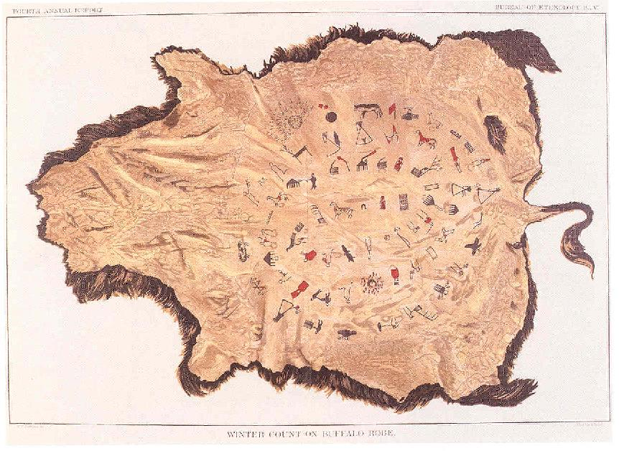

“Winter Count on Buffalo Robe” replica of Reed’s cloth copy of Lone Dog’s Winter Count published by the Bureau of American Ethnology (1886).

### Copies of the Lone Dog Winter Count Extant

There are 7 extant copies of Lone Dog’s Winter Count world-wide. Below is a list of the locations of these and references to their being cited in the literature.

#### Canada

**1. Riding Museum**, Provincial Park, Manitoba. Howard 1960b, 1979

**Buffalo National Park**, Alberta. Barbeau 1960:229. Destroyed by fire.

#### United States

**2. Atlantika Museum**, Swampscott, Massachusetts. A copy with variations and additions of ending years (1800-1884).

**3. Galena and Jo Daniess County Historical Society**, Galena Illinois. Collected by C. L. Gurley, 1871. #81.444A.

**4-5. National Museum of the American Indian**, Washington, D.C. *Photographs only* of 3 copies A, B, C on cloth. Photographs only of Mallery’s re-creation of the Winter Count on buffalo hide, original not located. See Greene and Thornton 2007). Two versons. One on deer hide, NMAI 23/246. A second version of the Lone Dog count painted on cow hide was acquired by the museum in 1952 from an antique dealer without any information on who made it or when. The entries are similar to the Lone Dog count as published by Mallery

**Nebraska State Historical Society**, Lincoln. *Textual interpretation only*. Susan Bettelyoun Bordeau Bordeaux and Waggoner 1988. Sundstrom 1997.

**6. South Dakota State Historical Society**, Pierre, South Dakota. #65.22 Capps 1973;21-22; Cash 1971:99-106

**Theodore Riggs**, San Francisco, California. Riggs 1958:250. Destroyed by fire in the San Francisco earthquake, 1907.

#### Germany

**7. Deutsches Ledermuseum**, Offenbach, Germany. Howard 1960b, 1979

|  |  |  |
| --- | --- | --- |
| |  | | --- | | This version of the Lone Dog count painted on deer hide was acquired by the museum in 1960 without any information on who made it or when. The entries are similar to the Lone Dog count as published by Mallery. NMAI 23/246. Courtesy National Museum of the American Indian. | |  |

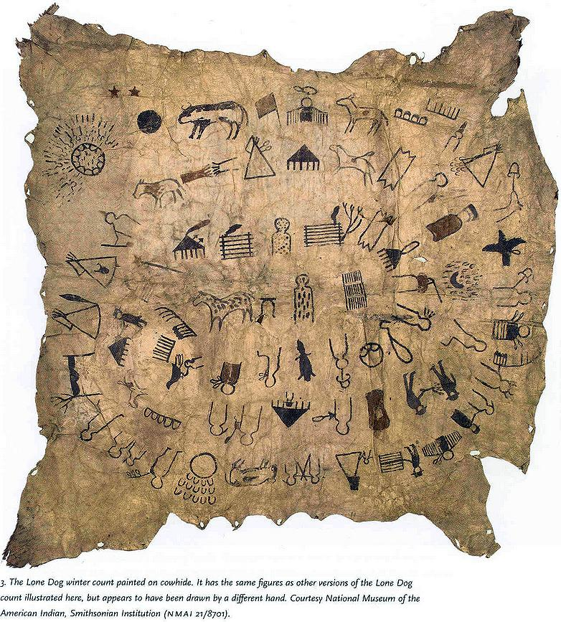 **Lone Dog Winter Count**, 1800-1870, on cow hide, 75" x 68" (190 x 173 cm) NMAI 21/8701. Courtesy National Museum of the American Indian.

This version of the Lone Dog count painted on cow hide was acquired by the museum in 1952 from an antique dealer without any information on who made it or when. The entries are similar to the Lone Dog count as published by Mallery.

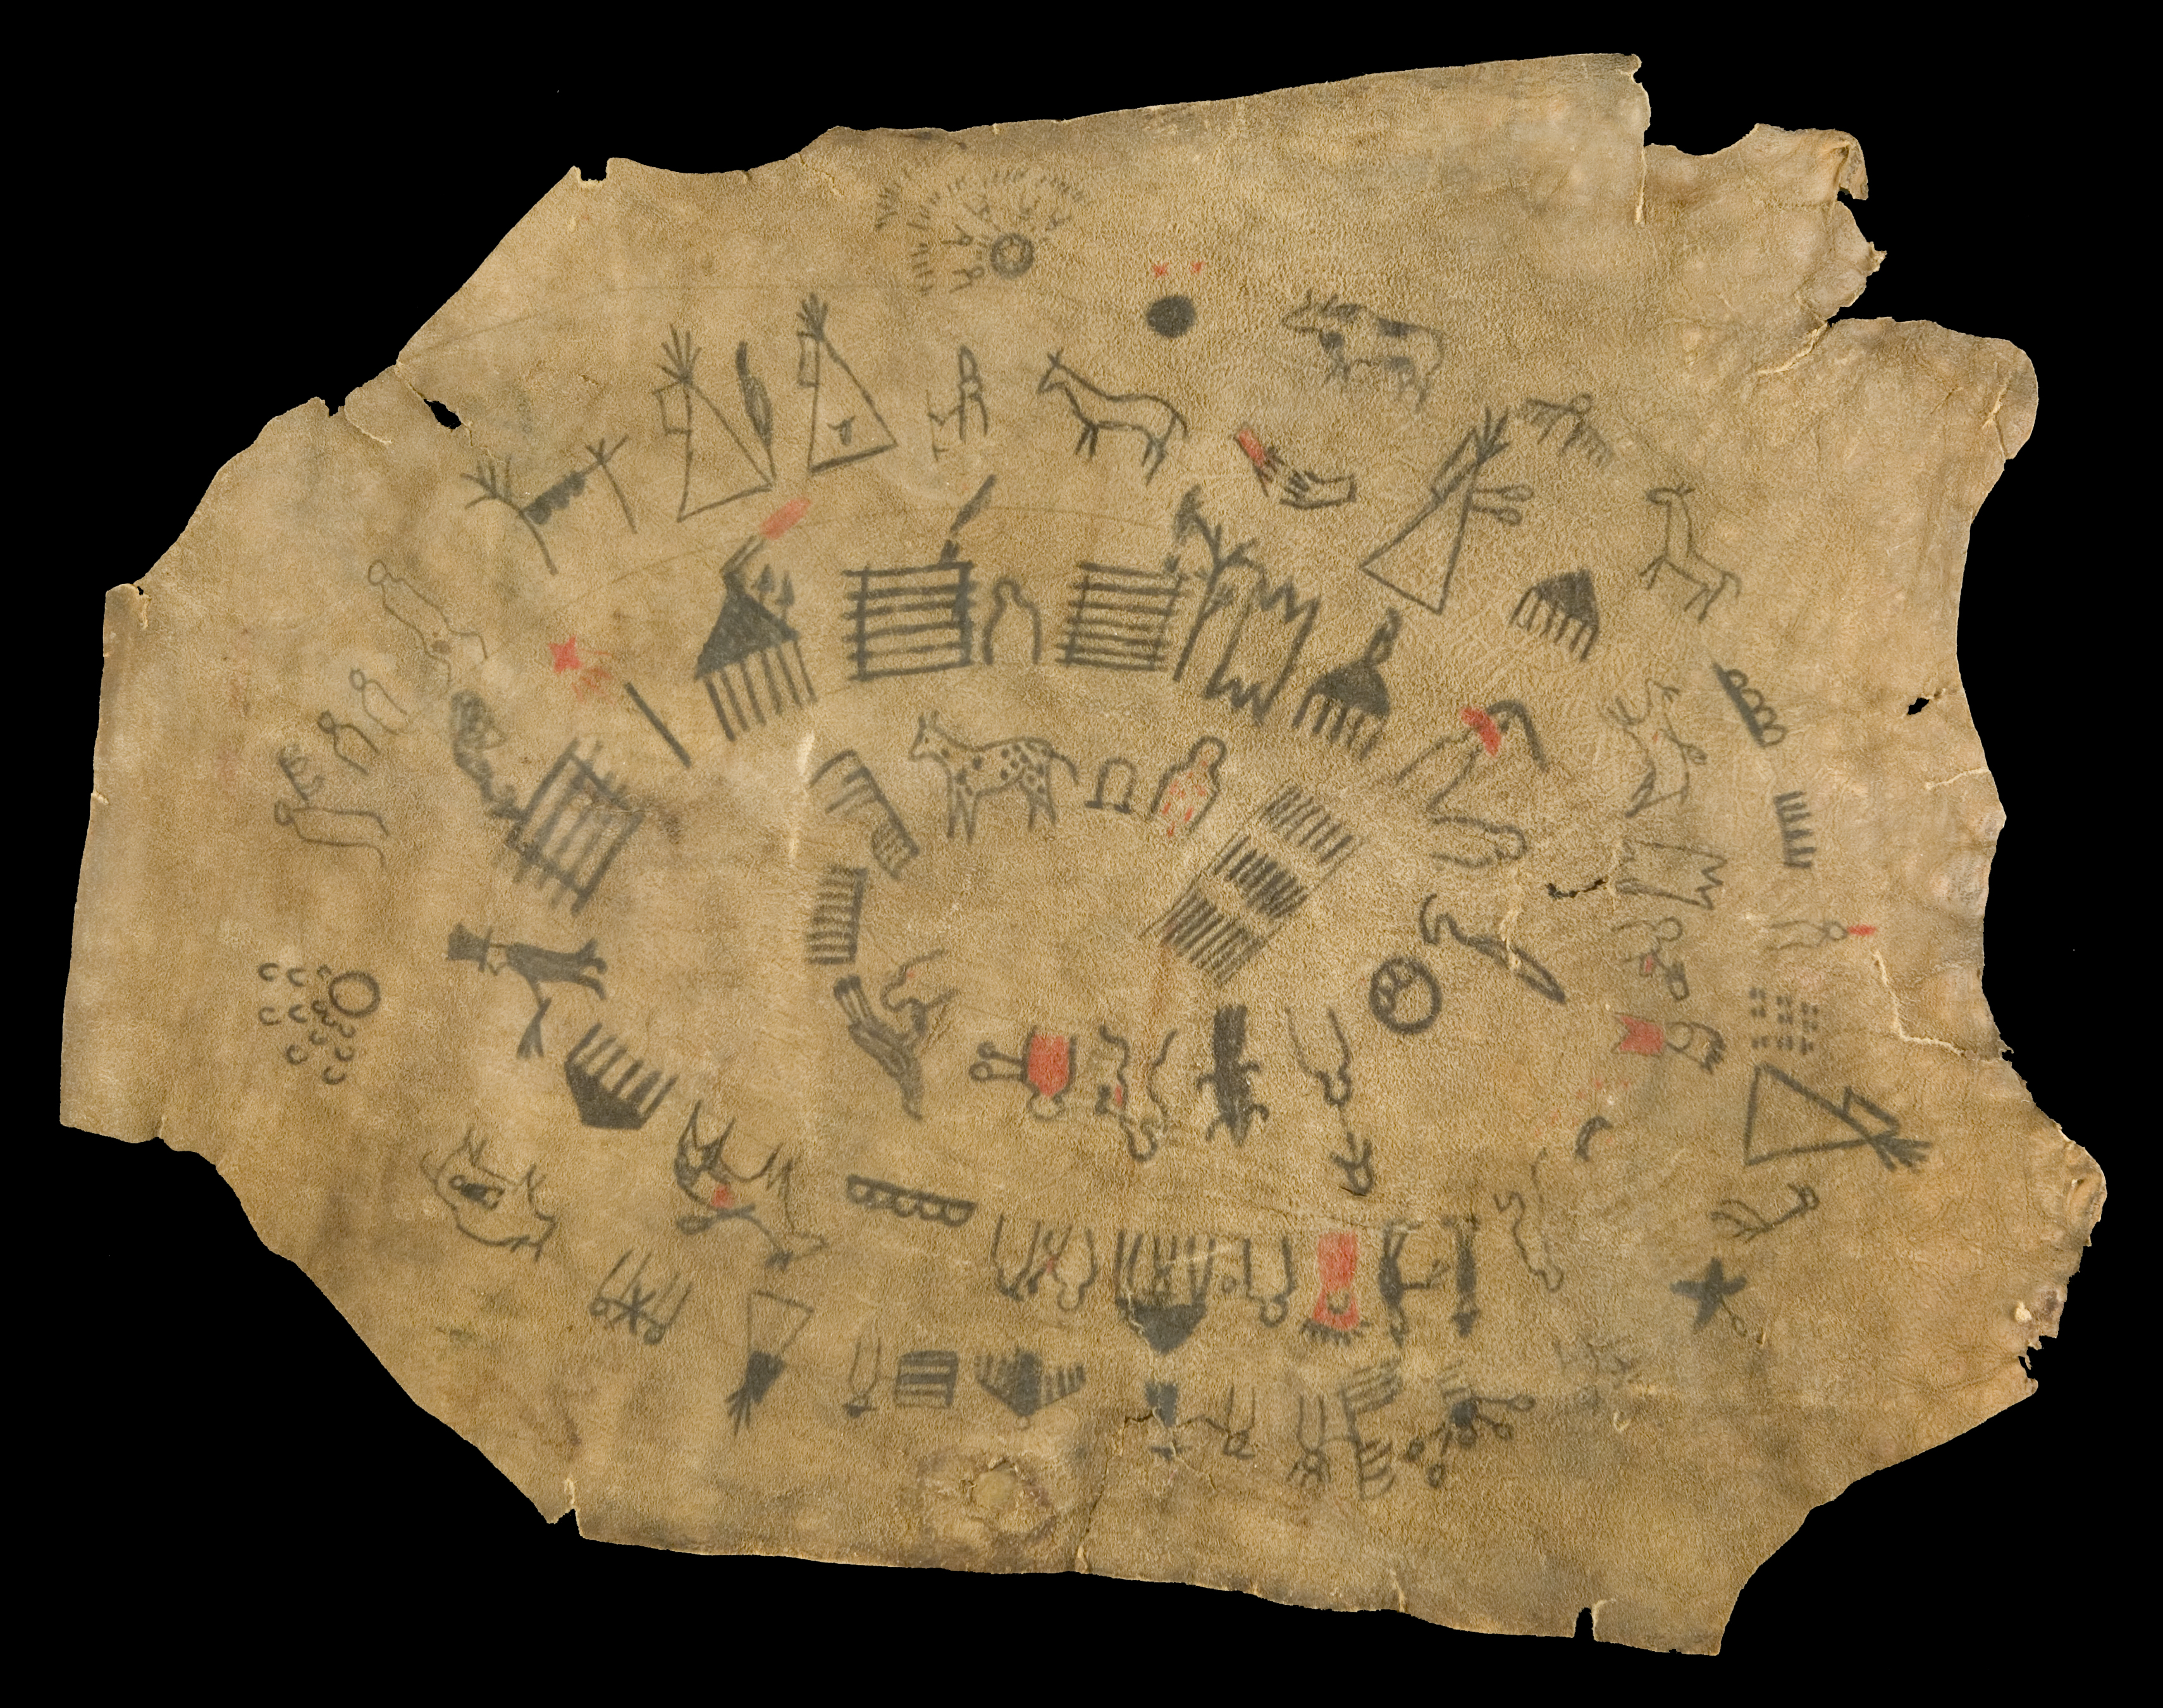

Lone Dog’s winter count.Tanned hide, paint1801-1876, South Dakota

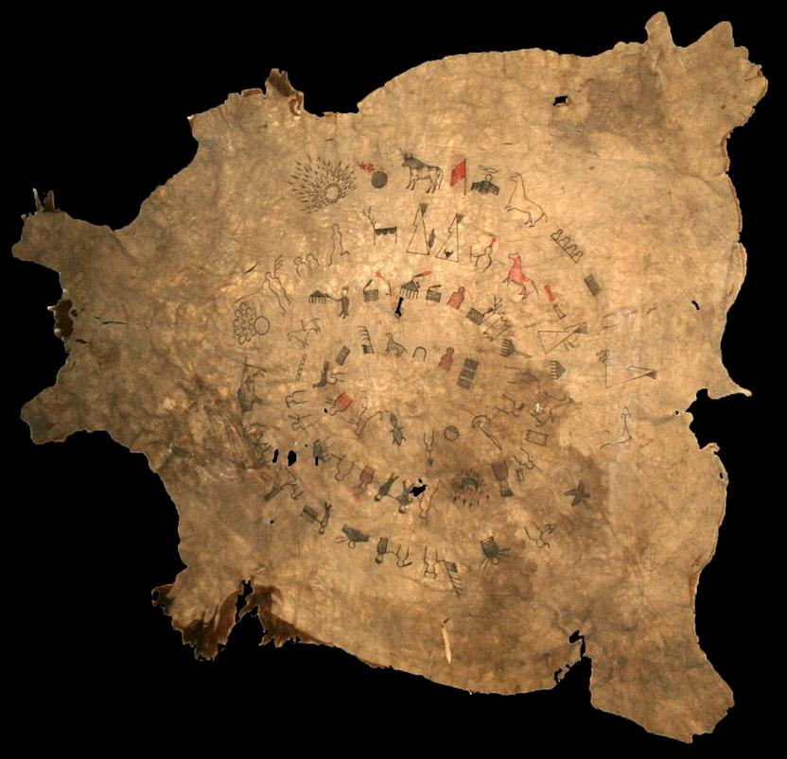

Lone Dog’s winter count.Tanned Buffalo hide The Museum of Native American History in Bentonville, Ark.

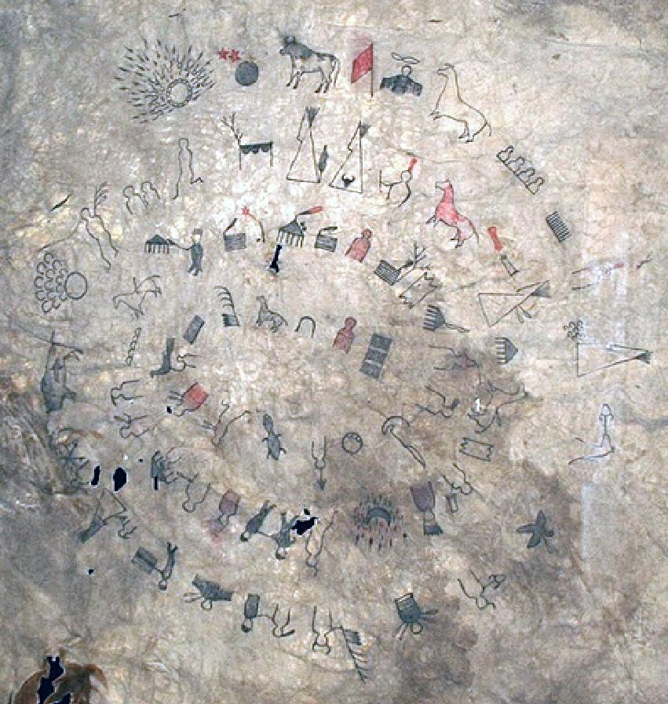

Lone Dog’s winter count.Tanned Buffalo hide The Museum of Native American History in Bentonville, Ark. Detail

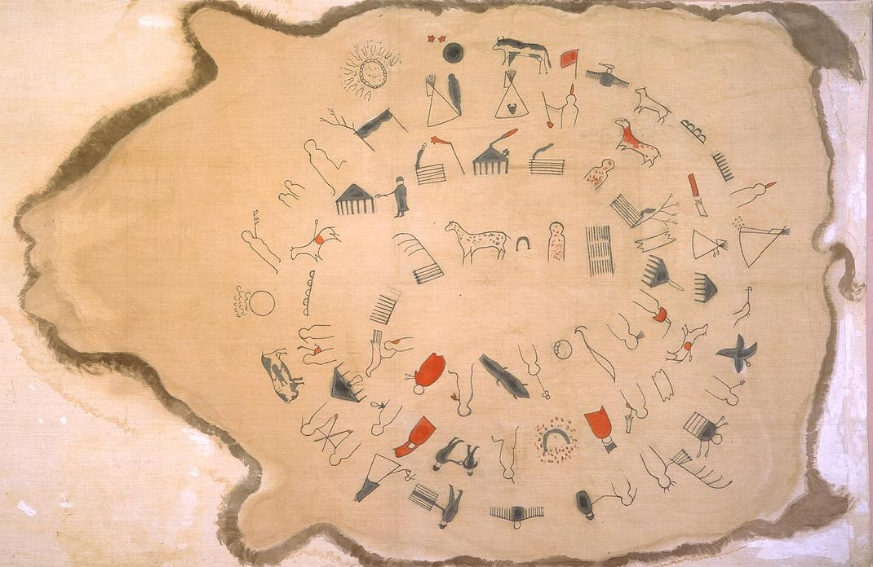

Lone Dog’s winter count on muslin (pictured above) that dates to the early 1900s. It records the years 1800 – 1801 through 1870 – 1871. Buffalo Bill Center of the West, Cody, Wyoming, USA. Museum Purchase. [*NA.702.5*](http://collections.centerofthewest.org/treasures/view/winter_count_sioux_fort_peck_indian_reservation_montana_muslin_paint_s) Accession Number: NA.702.5

Date : early 1900s

Dimensions: L: 36.625 in, width: 60.625 in

Remarks: Communication and Media of Exchange: Writing and Records. Painted and drawn on muslin in brown, black and red. Count starts at 1800-1801 and ends at 1870 - 1871. 70 small paragraphs. Copy of Lone Dog's winter count.

Inscription: Property of the Missionary Education Movement, stamped on back, lower right

Synopsis: winter count- Fort Peck Indian Reservation, Montana- Sioux- paint- muslin- Property of the Missionary Education Movement, stamped on back, lower right- Communication and Media of Exchange: Writing and Records. Painted and drawn on muslin in brown, black and red. Count starts at 1800-1801 and ends at 1870 - 1871. 70 small paragraphs. Copy of Lone Dog's winter count.

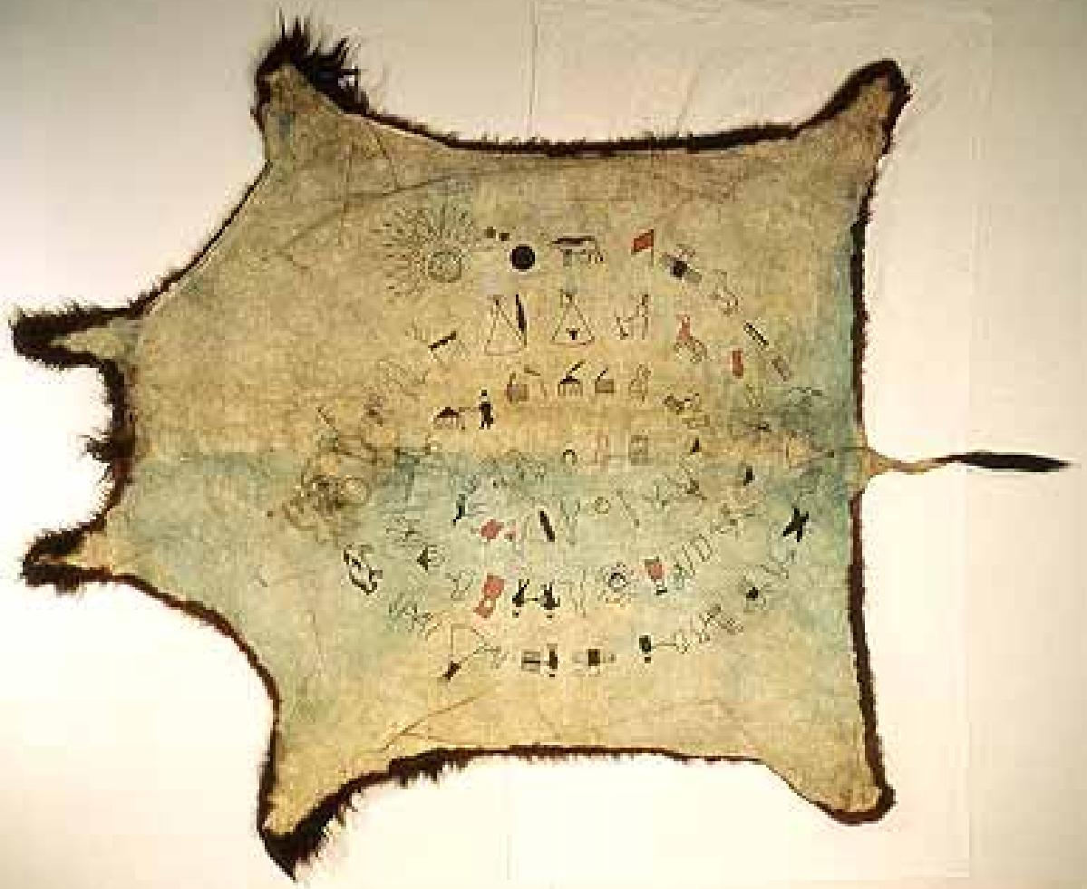

Winter Count or Calendar, ca. 1870 by Shunka Ishnala (Lone Dog, Sioux, lifedates unknown),60X84 in. Photo by Janine Jones. National Museum of the American India

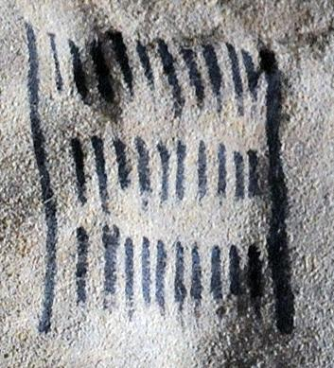

Atlantica pictograph for 1800-1801. Note: Mallery gives only one date, the first, for this and all succeeding pictographs. This practice does not accommodate the fact that the dating of the pictograph was from the year count that began with the first snow and lasted until the next succeeding first snow which could obviously over lap between two years..

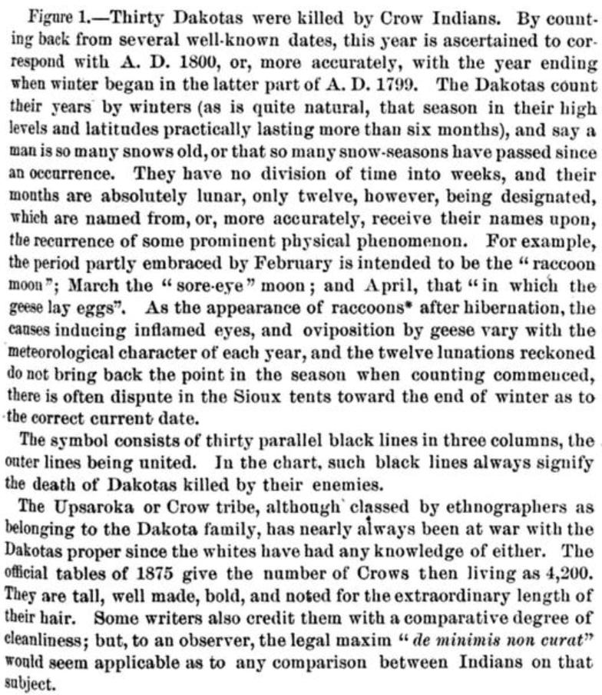

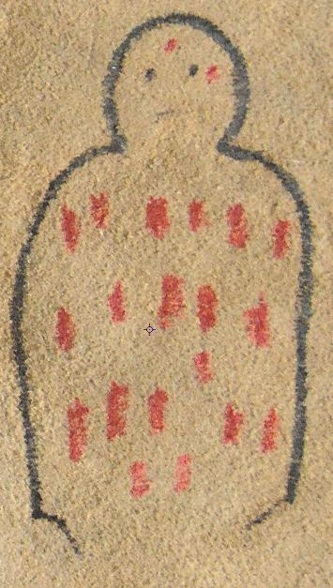

Atlantica pictograph for 1801-1802.



Note: In this rendition the facial features of a person are indicated, and red streaks suggest bleeding sores. This differs from the merely red blotches as indicated in the original Lone Dog Winter Count (Mallery 1893:273).

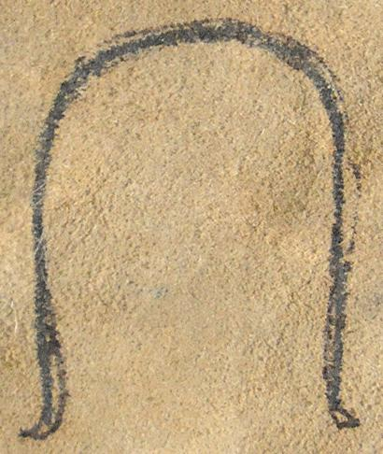

Atlantica pictograph for 1802-1803.



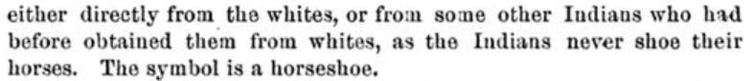

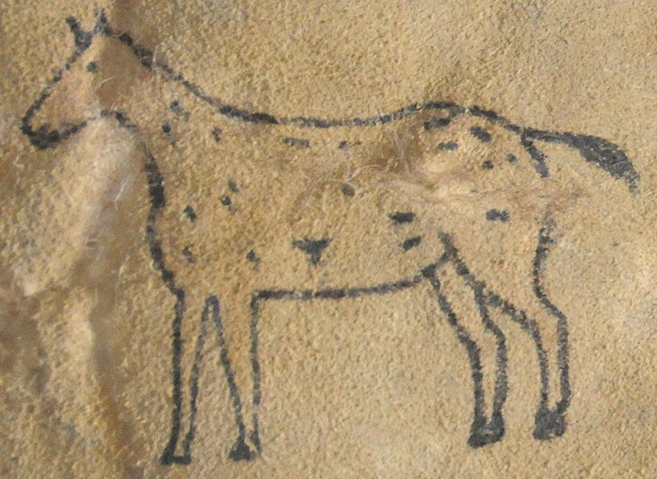

Atlantica pictograph for 1803-1804.

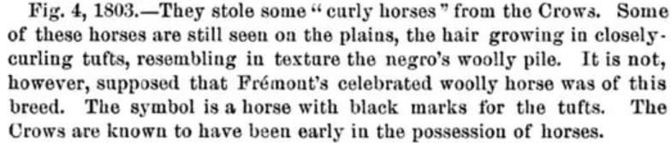

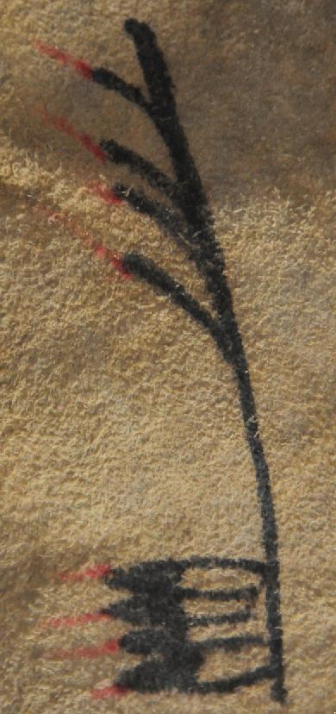

Atlantica pictograph for 1804-1805.

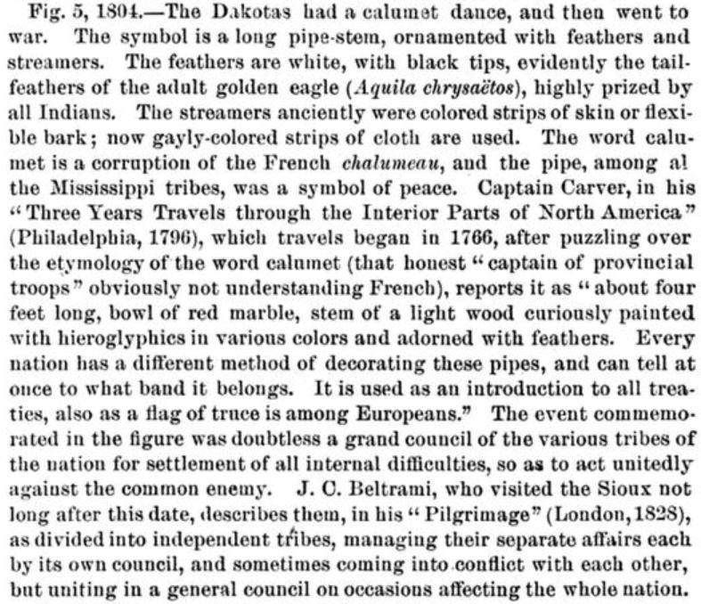

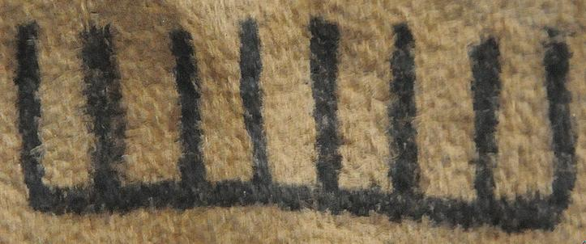

Atlantica pictograph for 1805-06. The Crows Killed eight Dakotas



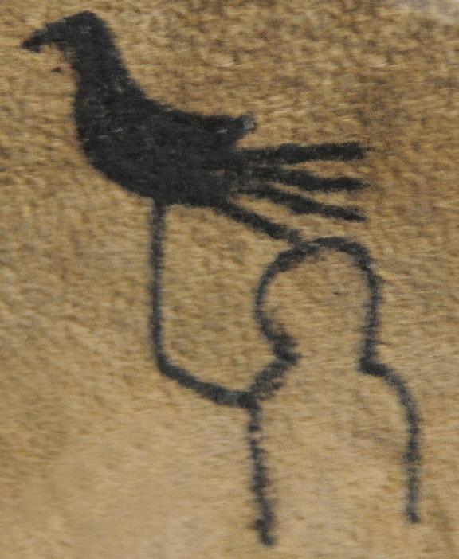

Atlantica pictograph for 1806-07, A Dakota killed an Arikara, as he was about to shoot an eagle.

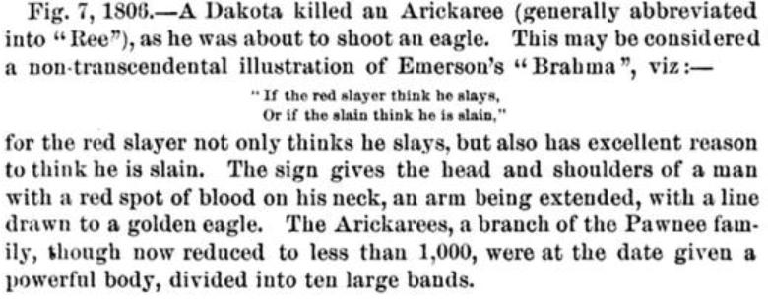

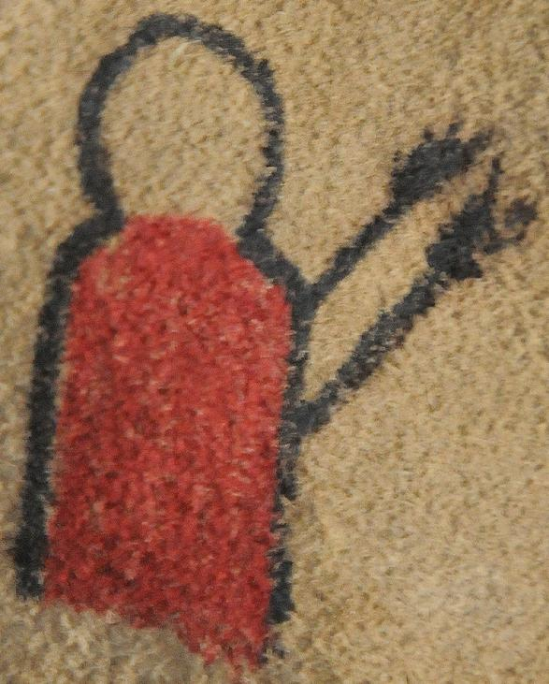

Atlantica pictograph for 1807-08, Red-Shirt, an Uncpapa Dakota, who had killed the Arikara as he was about to shoot an eagle, was, himself, killed by two Arikara Arrows (Mallery 1886:104-105).

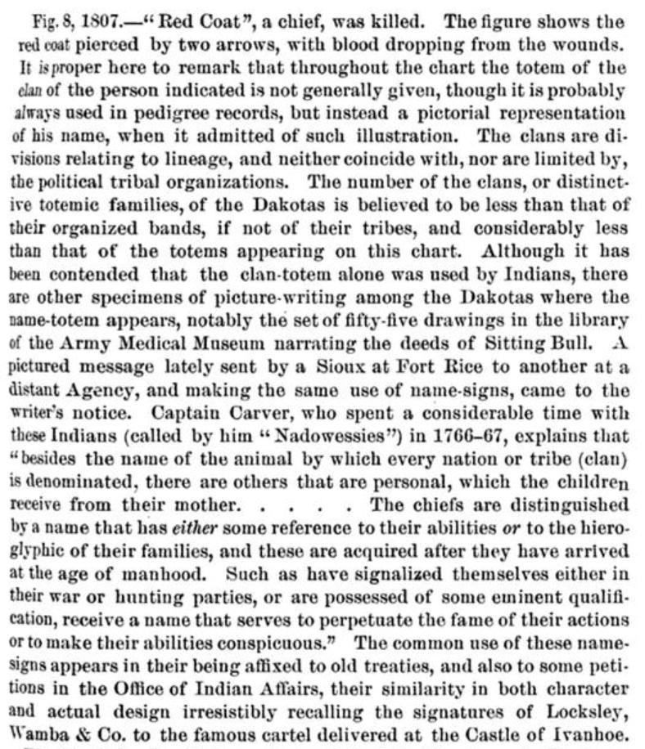

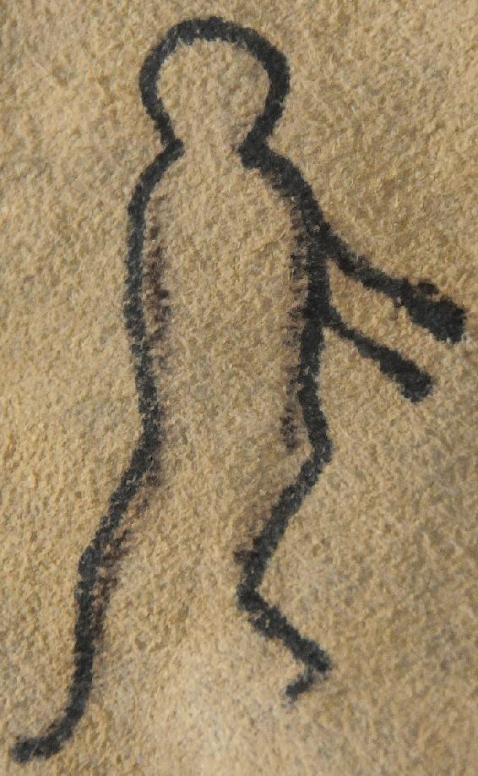

Atlantica pictograph for 1808-1809. The Dakota who had killed the Arikara was, himself, killed by the Arikara.

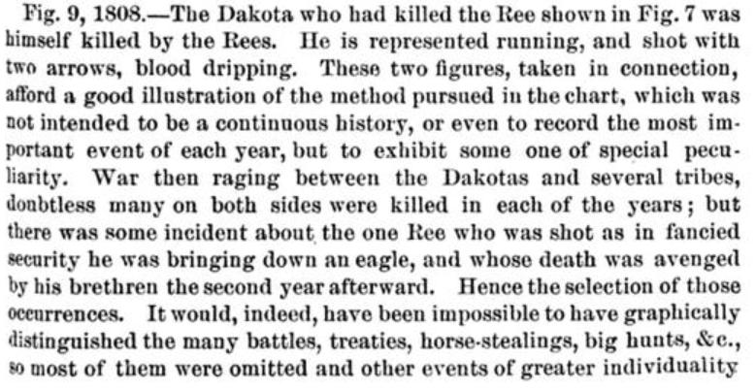 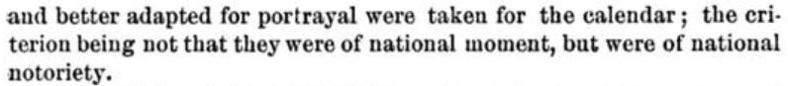

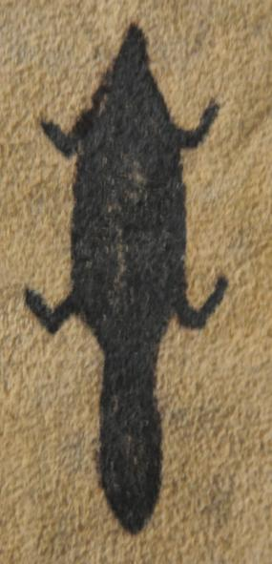

Atlantica pictograph for 1809-1810. Little Beaver, the name totem of a French white trapper, was given his name by the Lakota who liked him (Mallery1886: 106; Mallery 1893:275). His trading house on the Little Missouri River caught fire by accident (The Flame Winter Count, 1809-1810), and he was blown up by the gunpowder. White Cow Killer says that this year was “Little beaver’s house-burned down winter” (Corbusier 1886:135).

Note: This white trader is mentioned by Cloud Shield for 1803-1804. Other Winter Count’s place this event at 1809-1810.= (Cloud Shield, Battiste Good, Rosebud).

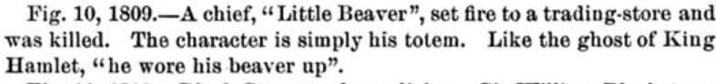

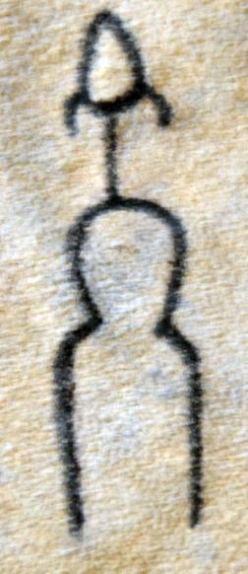

Atlantica pictograph for 1810-1811.

“Black Stone made medicine. “ The sign above the human figure who is Black-stone, a shaman, is an inverted white or albino buffalo that was revered especially for its spiritual powers for being so rare. Shamans were especially gifted individuals among the Lakota and the name Black-stone may refer to a special amulet that this individual held in reverence for its powers of the earth while the inverted white buffalo skull is pointed toward the heavens, thereby facilitating the shaman’s power to connect the heavens and the earth. The Swan, Major Bush and Rosebud Winter Counts indicate that this year Black Rock initiated in his shamanism while The Flame and American Horse (1809-1810) Winter Counts indicate that Black Rock died. It is suggested that the death referred to was the spiritual death to his mundane existence and the beginning of Black Rock’s new shamanic life. For instance, The Swan Winter Count elaborates the event of this year by indicating “A Minneconjou Dakota, named Little Tail [i.e., Black Rock], first made ‘medicine’ with a white buffalo cow-skin” (Greene and Thornton 2007:148), and this was corroborated for this year by Mato Sapa (Mallery 1886:107).

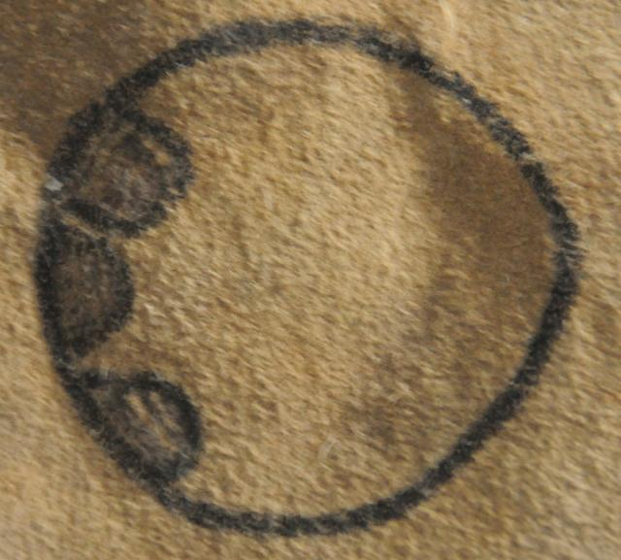

Atlantica pictograph for 1811-1812.

The Dakota fought a battle with the Gros Ventres and killed a great many in a round dirt lodge. The circle (the round dirt lodge) encloses three round objects, which are severed heads of enemies slain in battle. In the sign language of the Dakota a hand across the throat signified they cut the throats of their enemies and there appear to be slashes across the heads portrayed here..

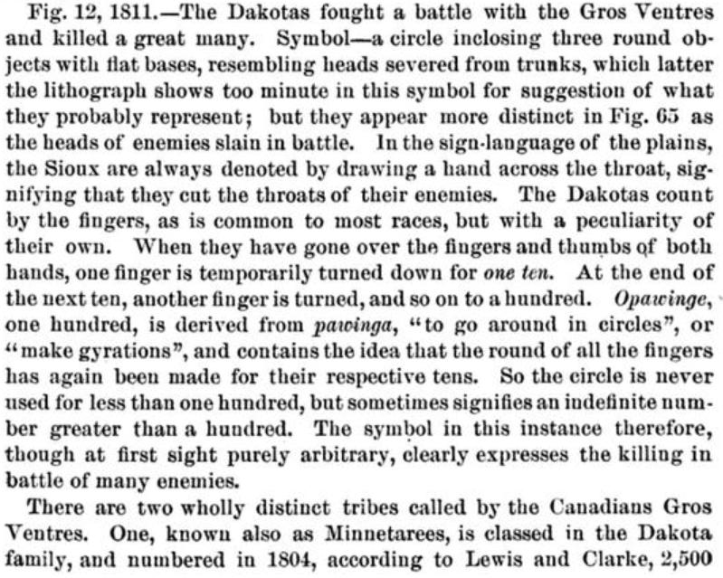 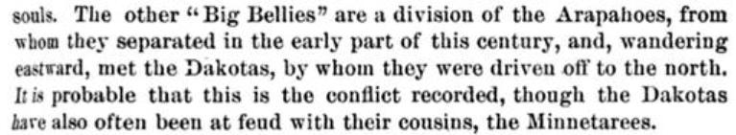

(Mallery 1877)

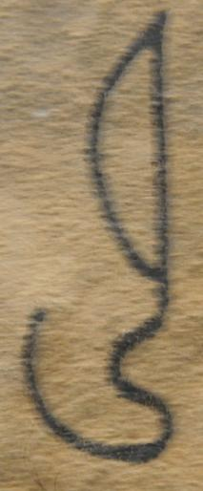

Atlantica pictograph for 1812-1813.

Wild horses were first run and caught by the Dakotas using a lariat or lasso, which is pictured here. This establishes the timing of the arrival of the wild descendants of the Spanish horses that were first brought into Mexico in 1520. This pictograph establishes they had migrated north by 1812-1813 into the Missouri River area.

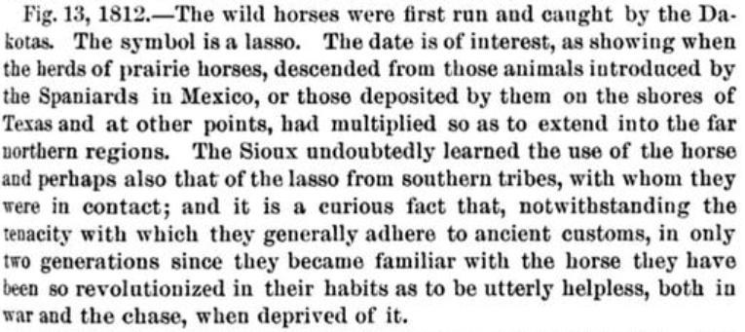

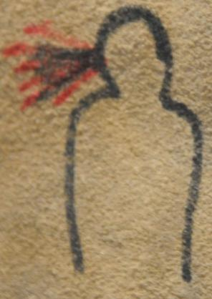

Atlantica pictograph for 1813-1814

The whooping cough was very prevalent and fatal. In the sign here the coughing of blood is shown along with the black sputa in the end stages of the disease (Mallery 1893:276). Apparently Mallery had not witnessed this disease.

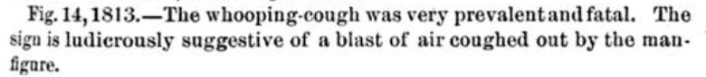

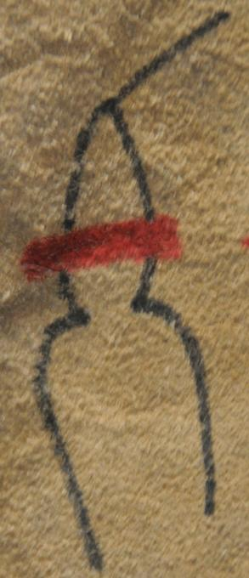

Atlantica pictograph for 1814-1815.

A Dakota killed an Arapaho in his lodge. The sign represents a tomahawk cleaving a skull with blood issuing forth. In other Winter Count’s the victim is identified as a Kiowa (American Horse Winter Count, The Swan Winter Count) or a Brulé killed by Utes (The Flame Winter Count).

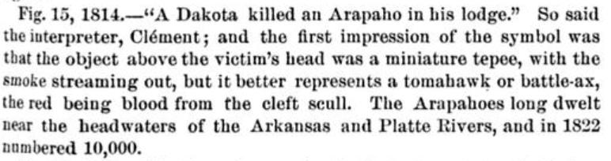

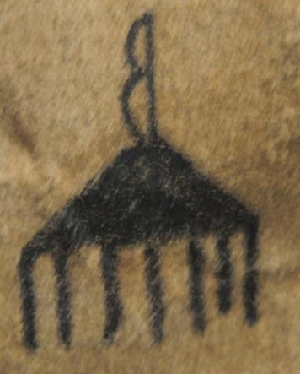

Atlantica pictograph for 1815-1816.

The Sans Arcs, a subdivision of the Lakota, under their Chief Crow Feather made their first attempt at constructing an earth lodge at Peoria Bottom [now Peoria Flat], Hughes County, South Dakota, named for a steamboat named *Peoria*, which went aground there. The figure at the top of the solid triangle is a strung bow, which refers to the name Sans Arc or Without Bow, or in Lakota “**Itázipčho,”** ‘Those who hunt without bows.’ The negation of the bow (Sans Arc) appears to be placing it facing to the left.

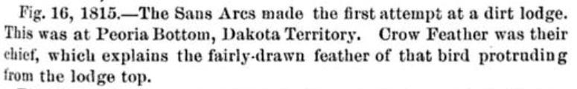

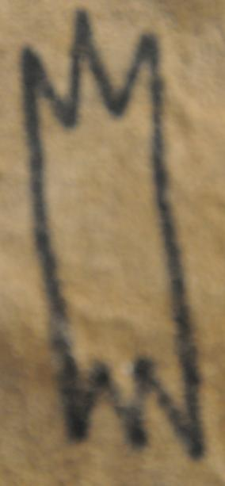

Atlantica pictograph for 1816-1817.

“Buffalo belly was plenty.” The sign indicates a carcass of a buffalo being hung out to dry, signifying a unusually successful hunt by the Dakota (Mallery 1886: 109). It is probable that this pictograph signifies not one but many hides being hung out to dry indicated by “plenty” before being tanned with buffalo brain. The subject is, however, the “belly” of the buffalo, which was a prized portion of the animal.



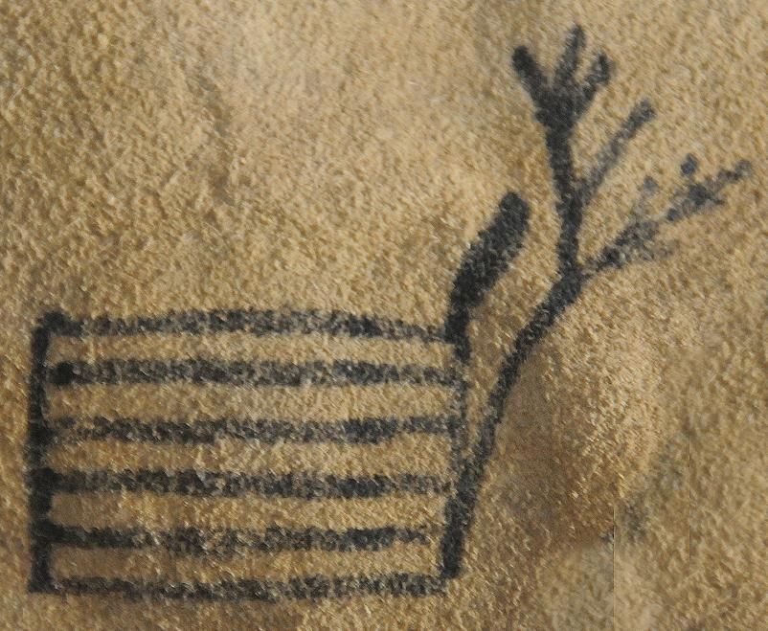

Atlantica pictograph for 1817-1818.

1818. Joseph La Framboise, a Canadian, built a trading store with dry timber. The dryness of the timber is indicated by the dead tree (Mallery 1886).

JosephLaFramboise, Sr., was a mixed-blood trader married to Oasixheaoui, a Dakota. They had a trading post at Pierre, South Dakota, from 1817 to 1822. It was the beginning of the oldest continuous white settlement west of the Missouri River (Clayton and Woolworth 2014).

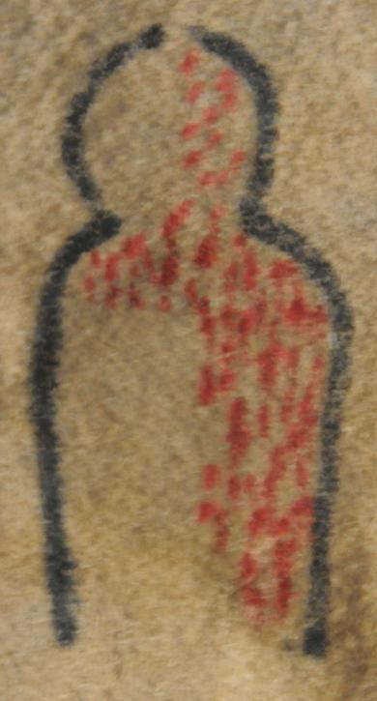

1818-1819.

The measles broke out and many died.

Note: The indication of the pustules from the measles is not evenly dispersed over the entire body as it was in the small pox epidemic of 1801-1802.

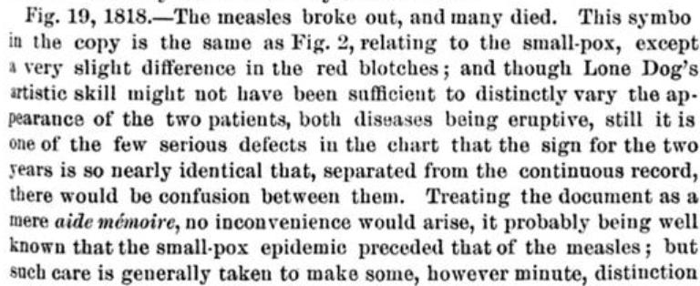 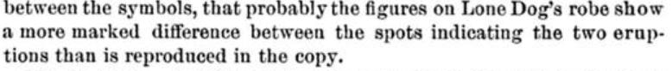

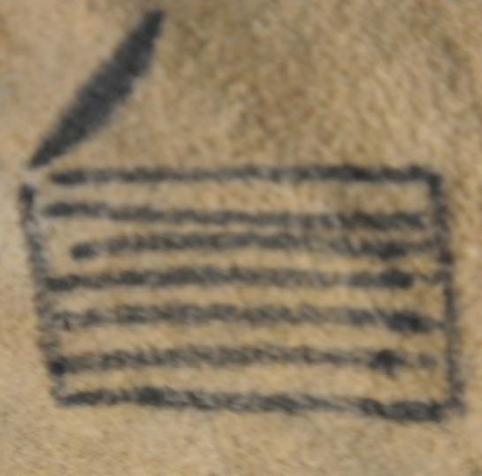

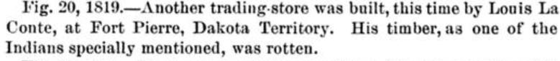

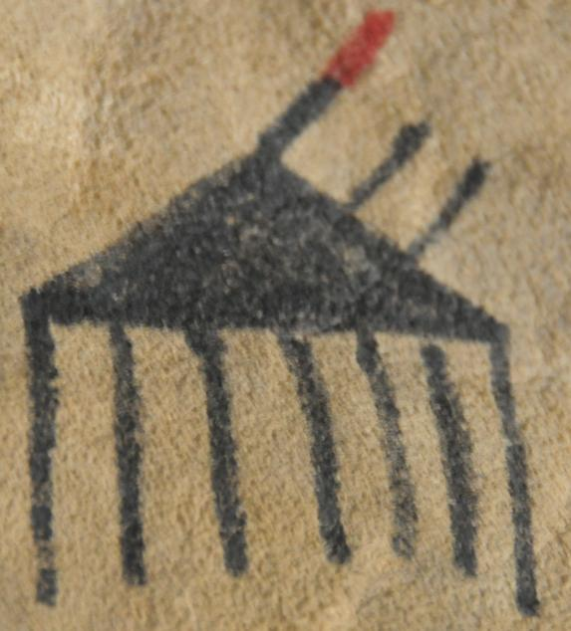

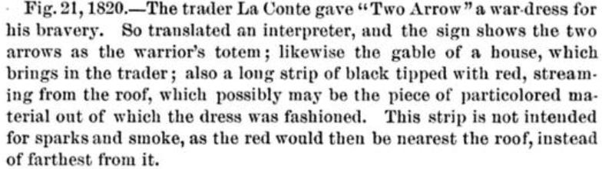

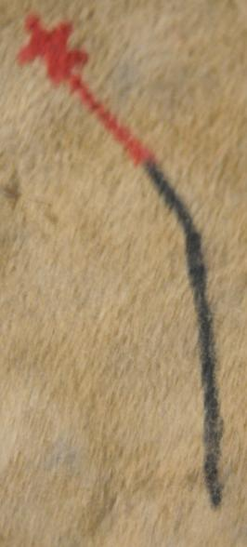

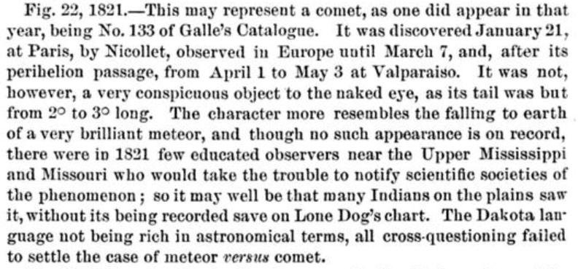

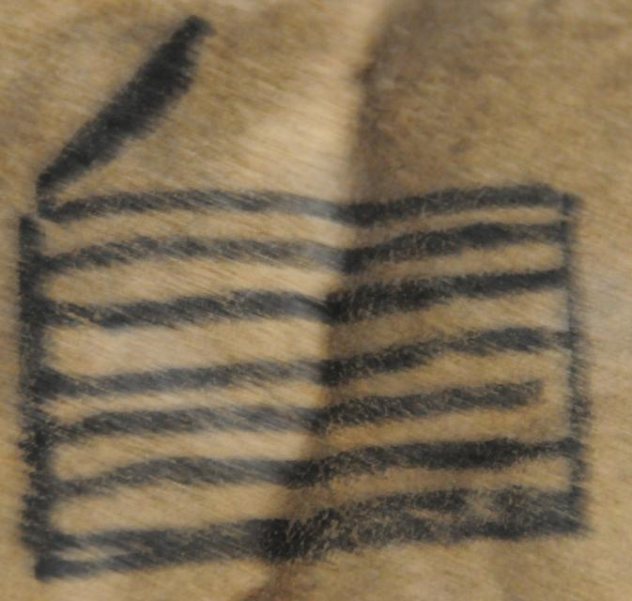

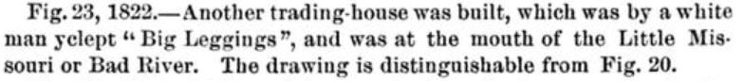

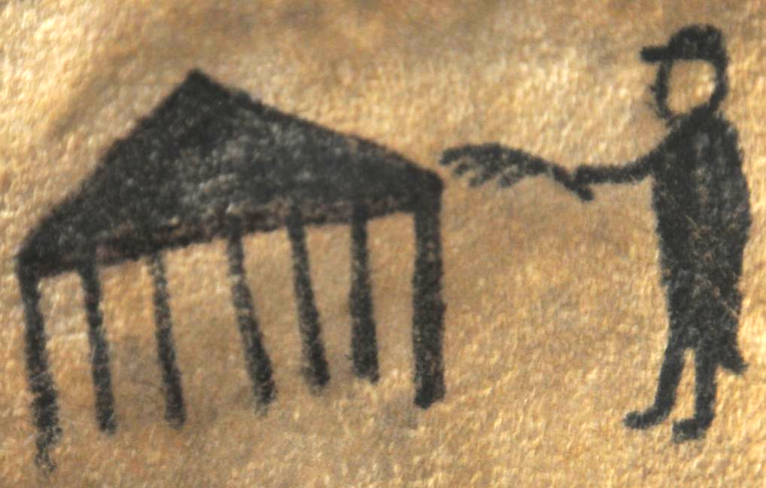

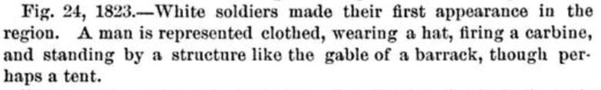

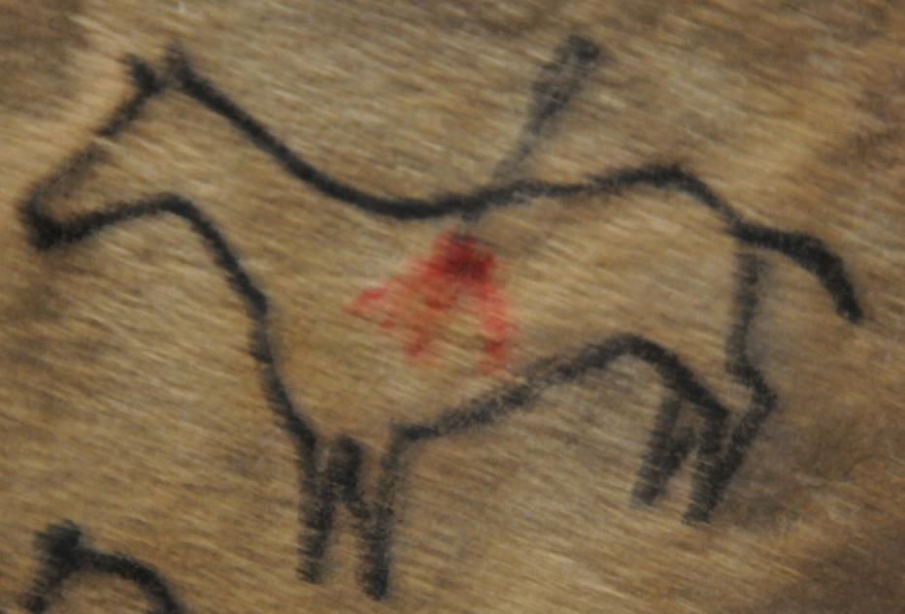

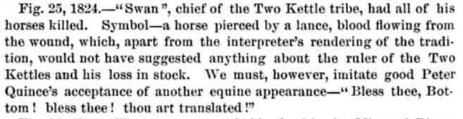

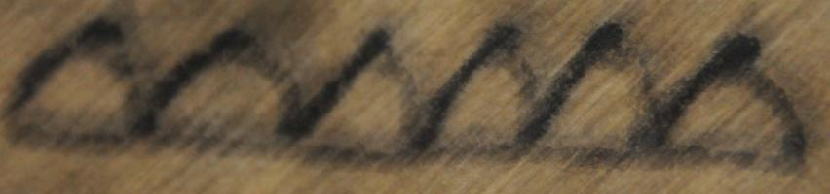

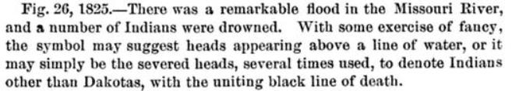 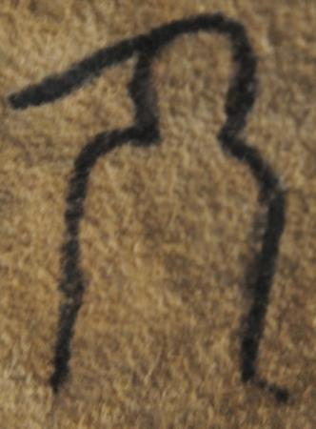

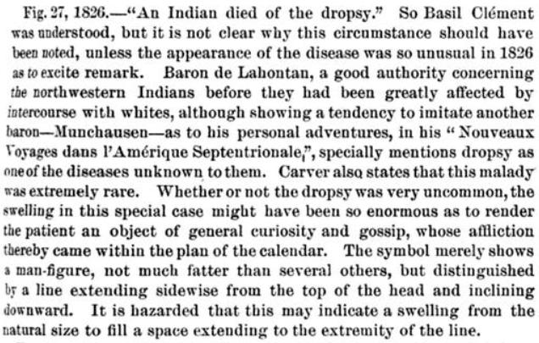

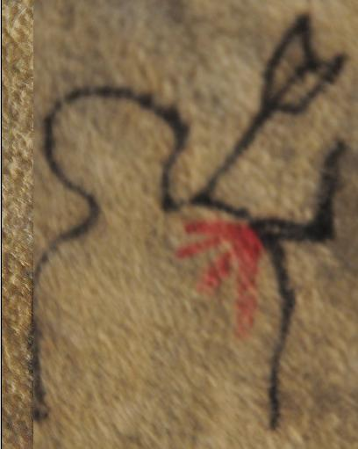

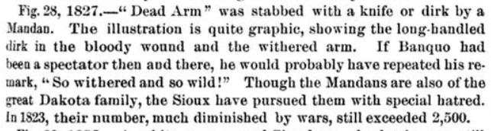 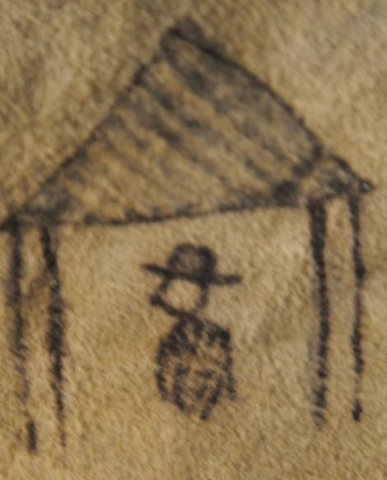

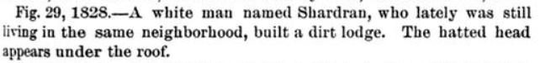 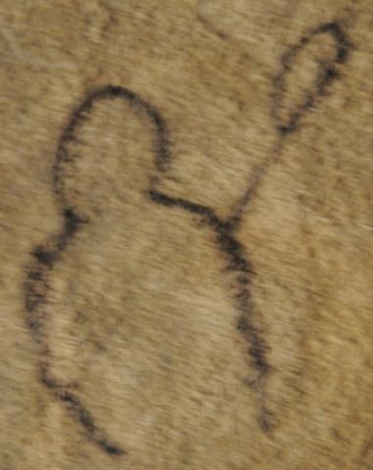

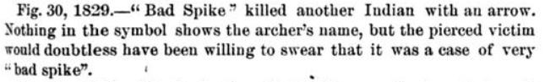 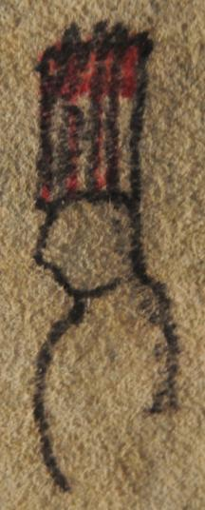

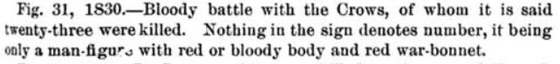 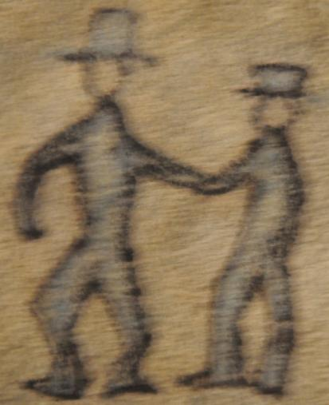

 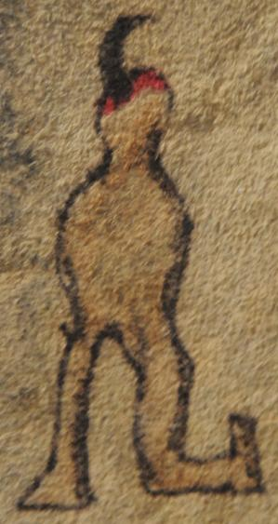

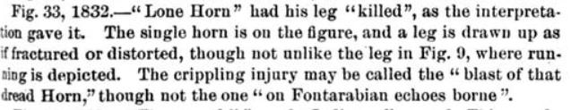

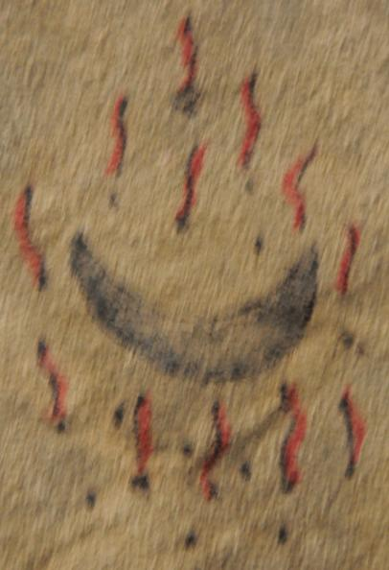

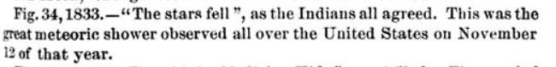

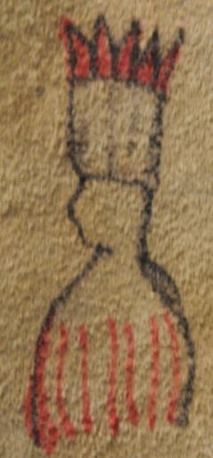

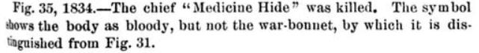

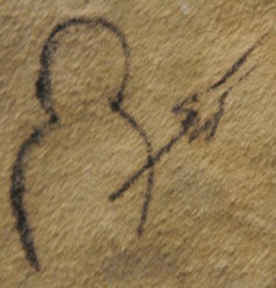

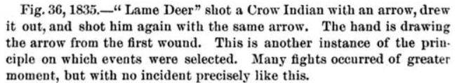

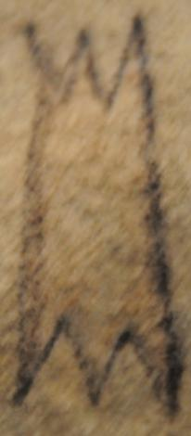



Note: This sign was used to designate the year when Buffalo Breast, father of Band, died. This sign was, therefore, a personal sign for Buffalo-Breast and although it is identical to 1816-17, “Buffalo belly was plenty,” the meaning pertained to the totem of Buffalo Breast.

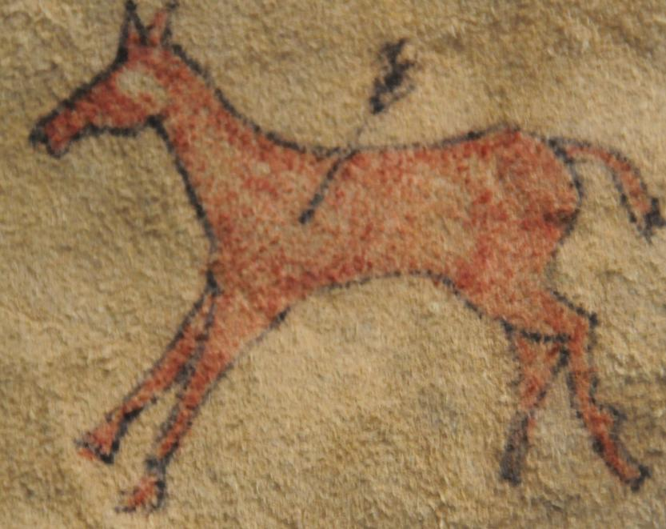

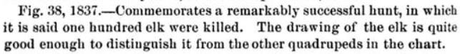

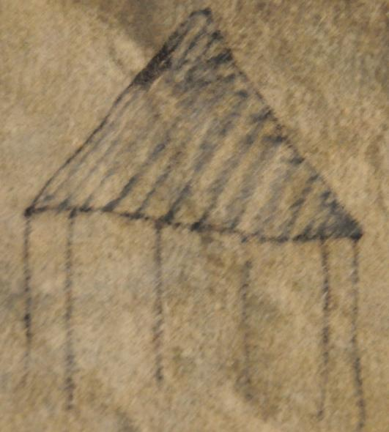

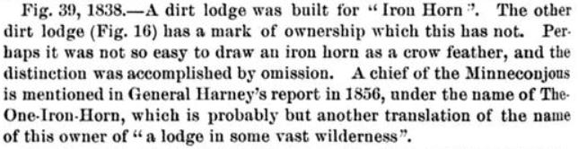

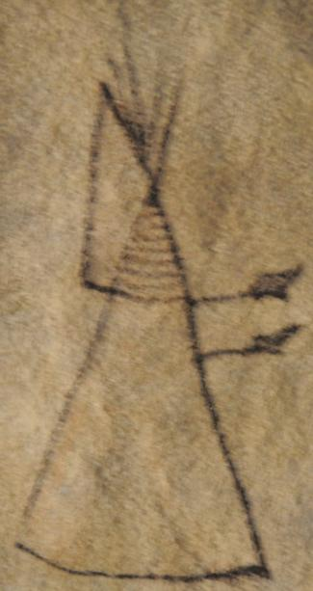

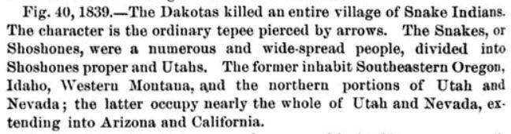

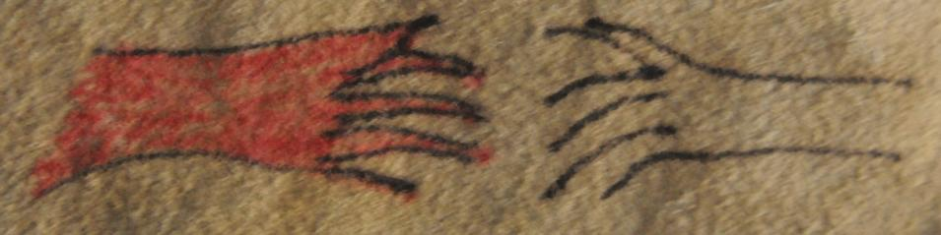

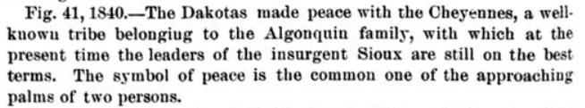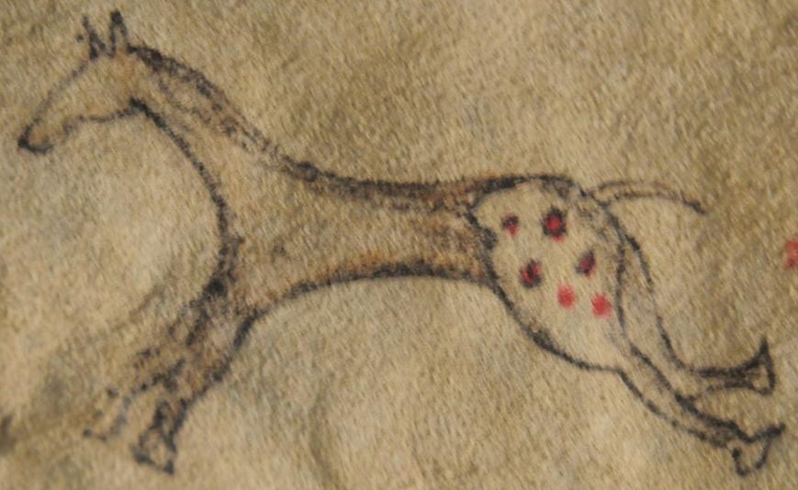

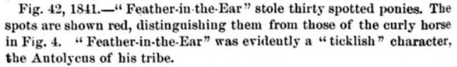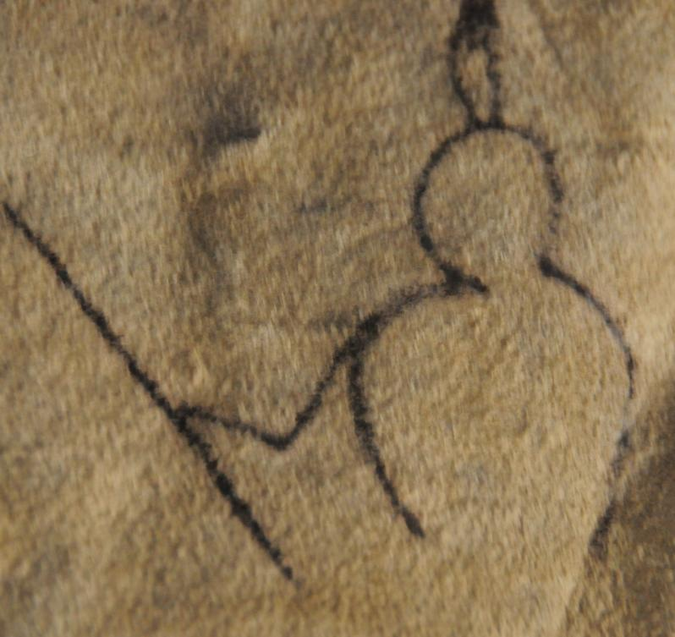

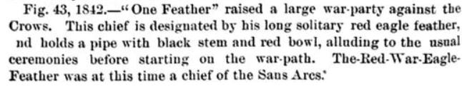

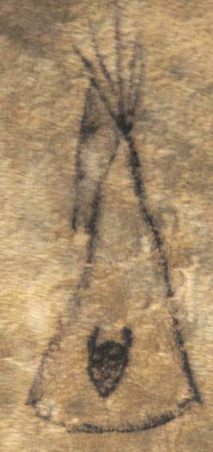

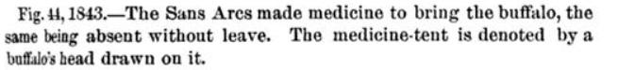

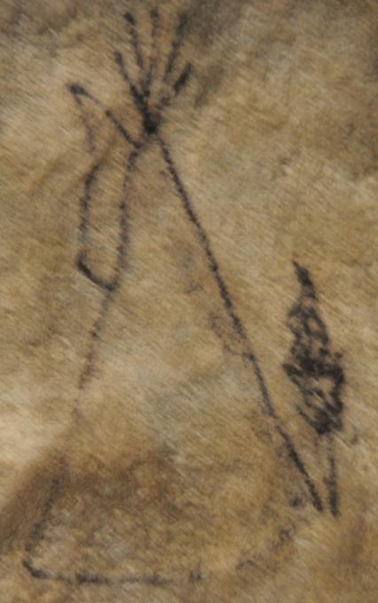

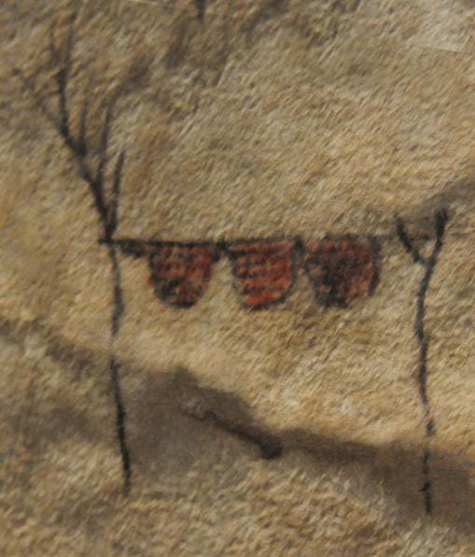



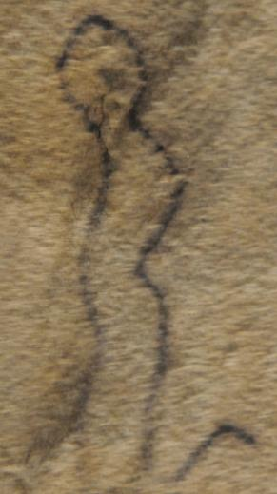



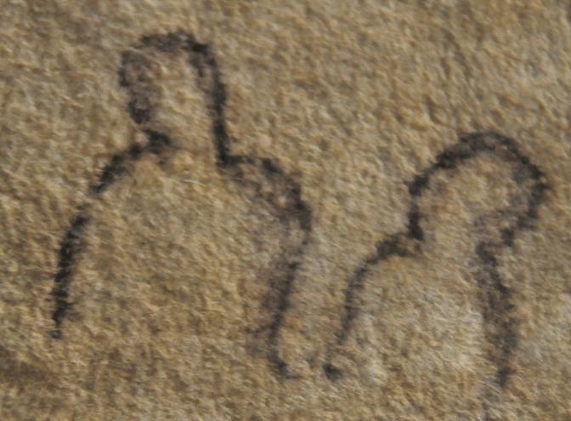



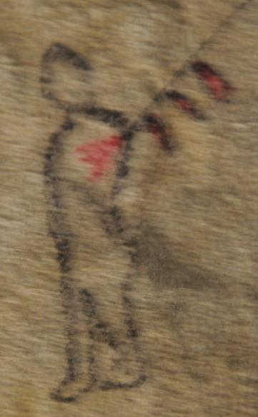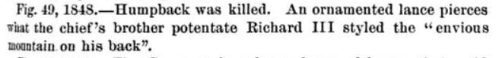

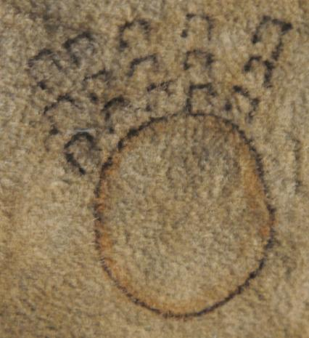

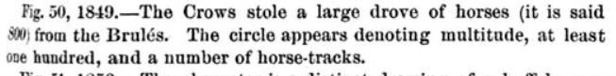

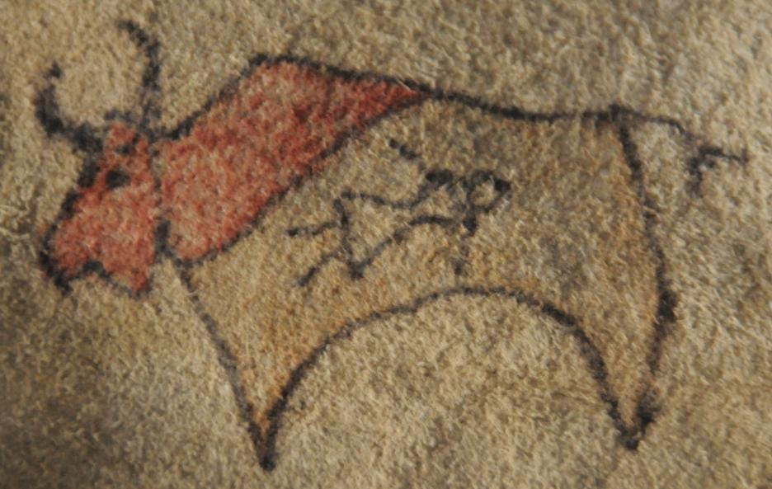

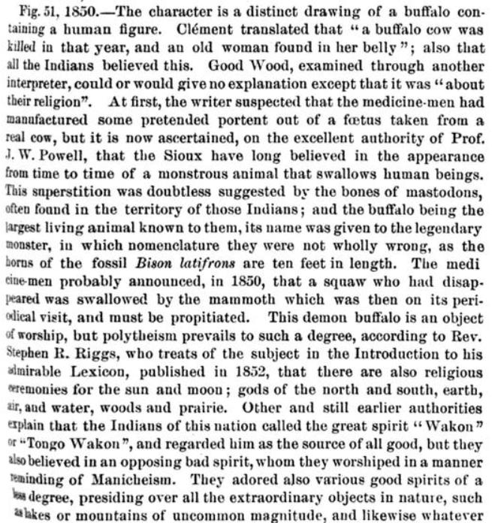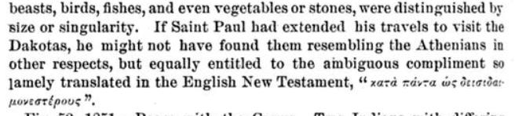

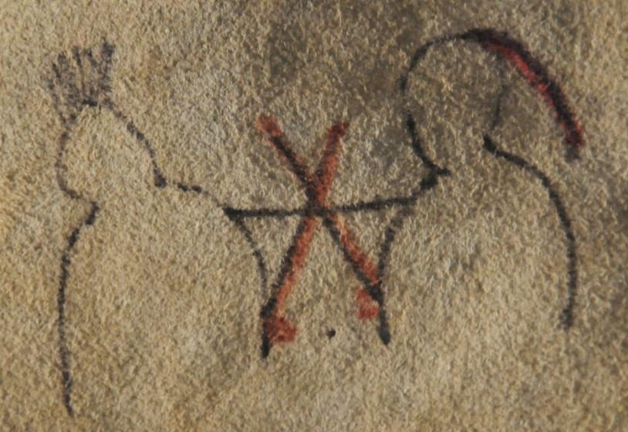

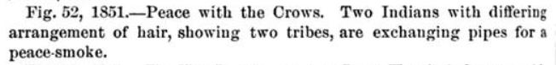

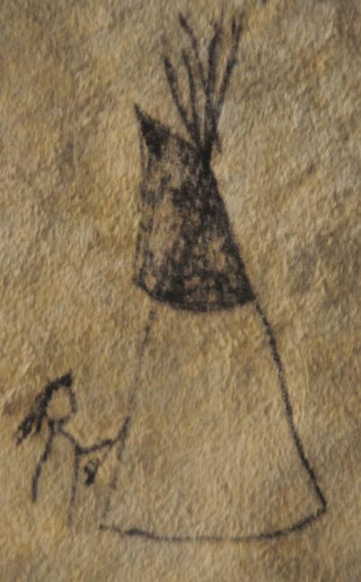

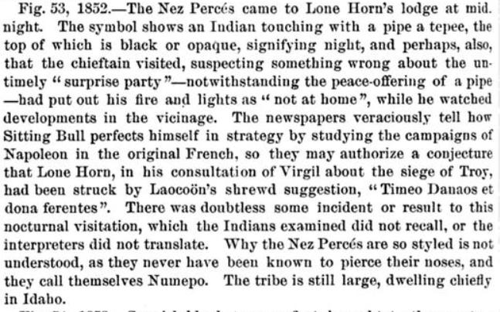

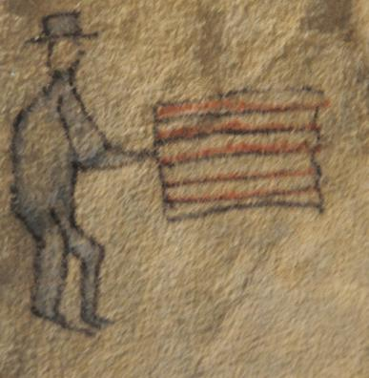

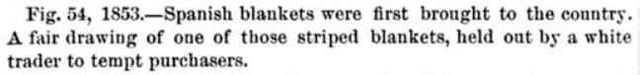



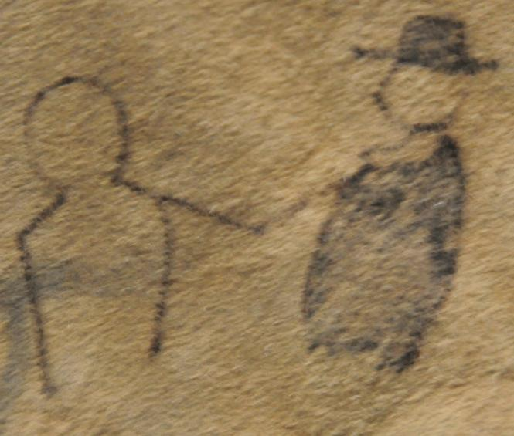

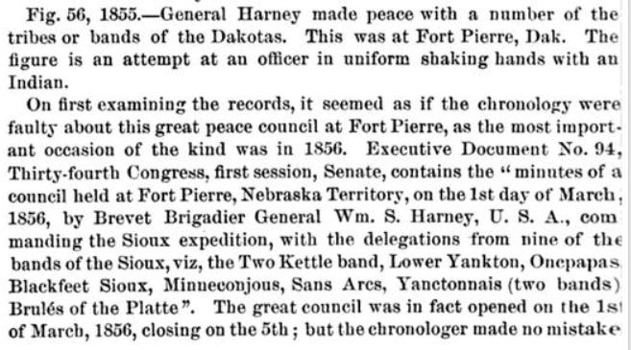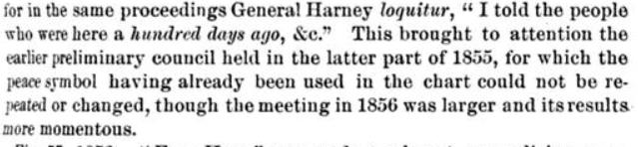

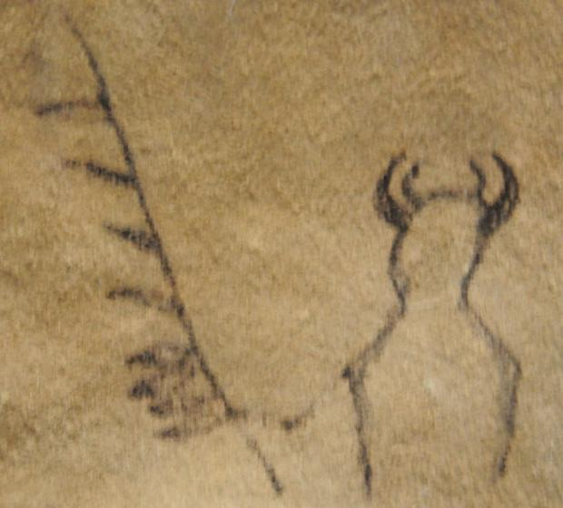

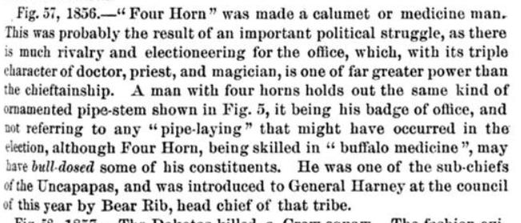

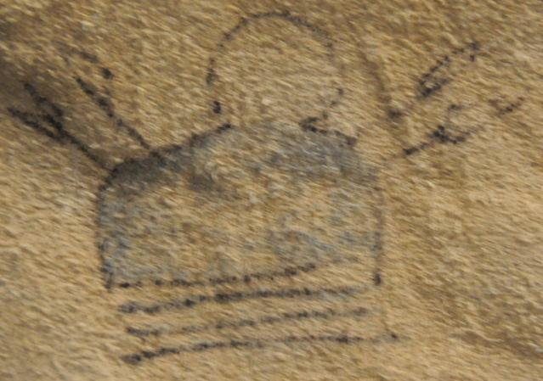

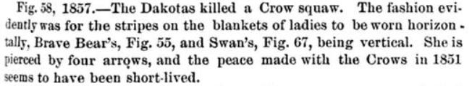

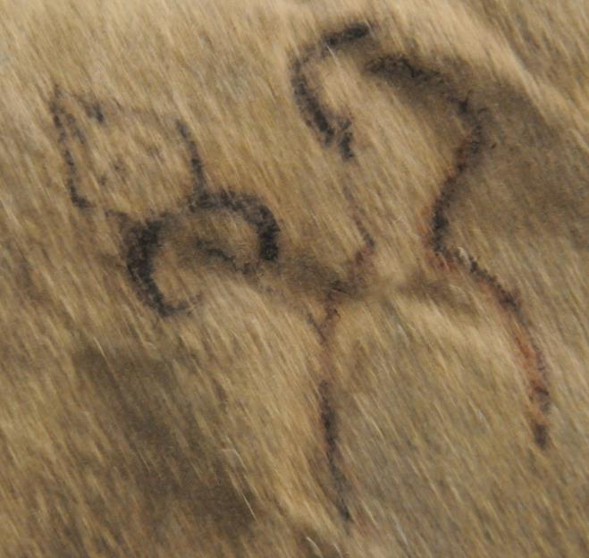

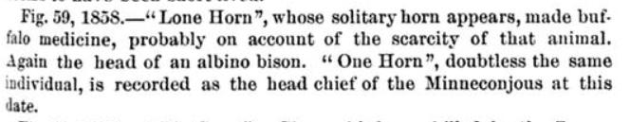

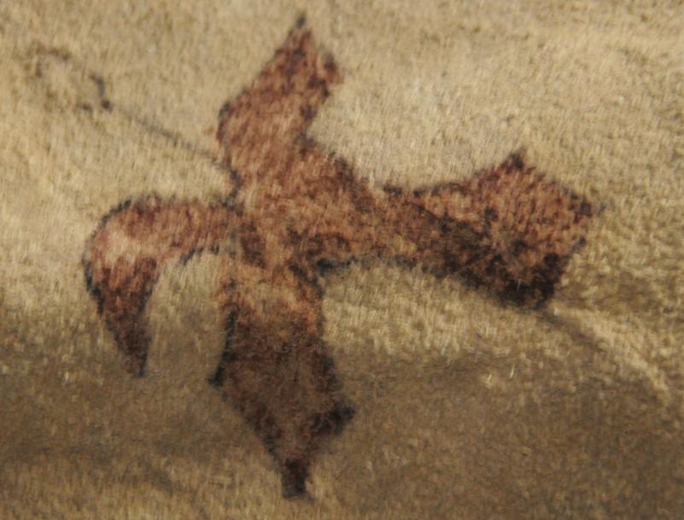

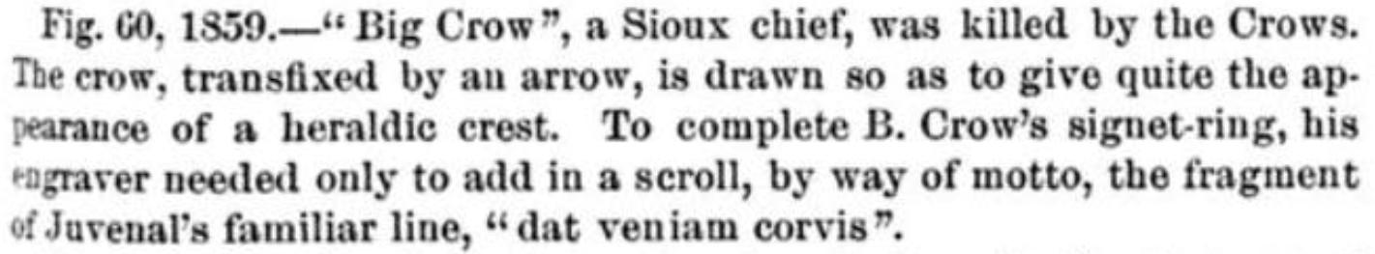

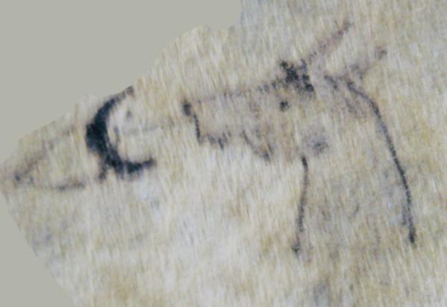

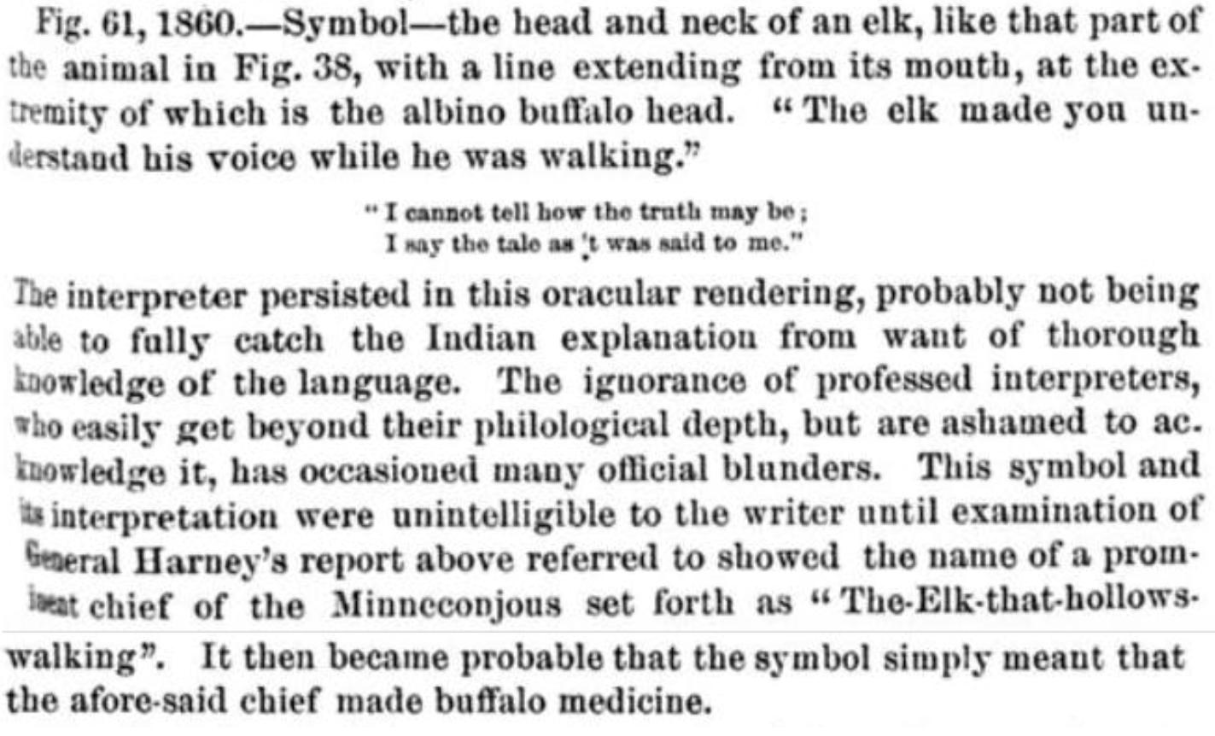

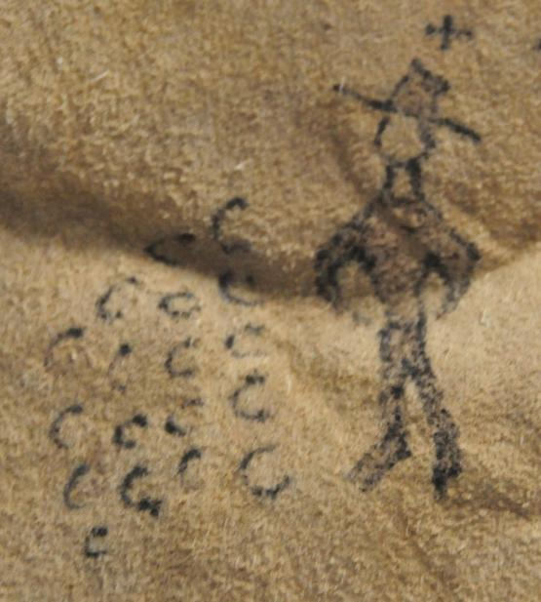

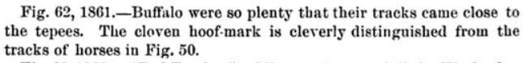

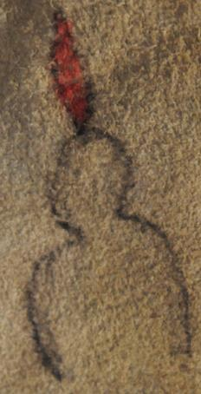



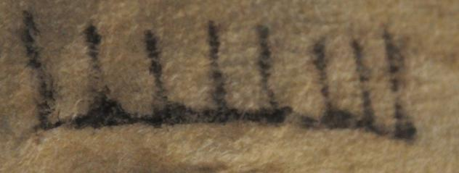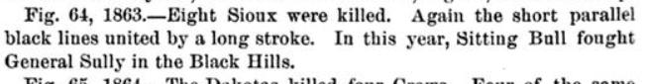

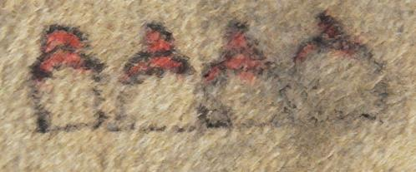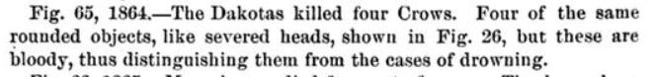

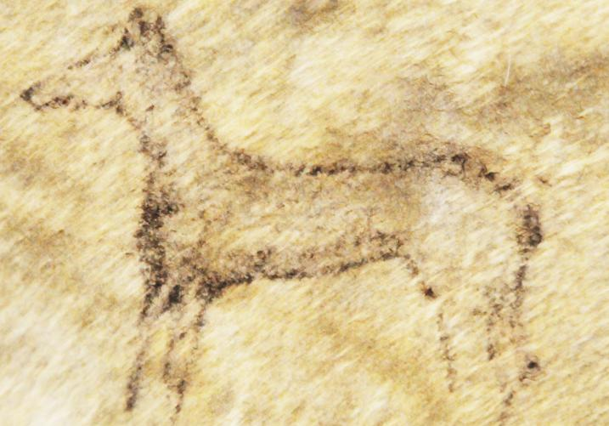



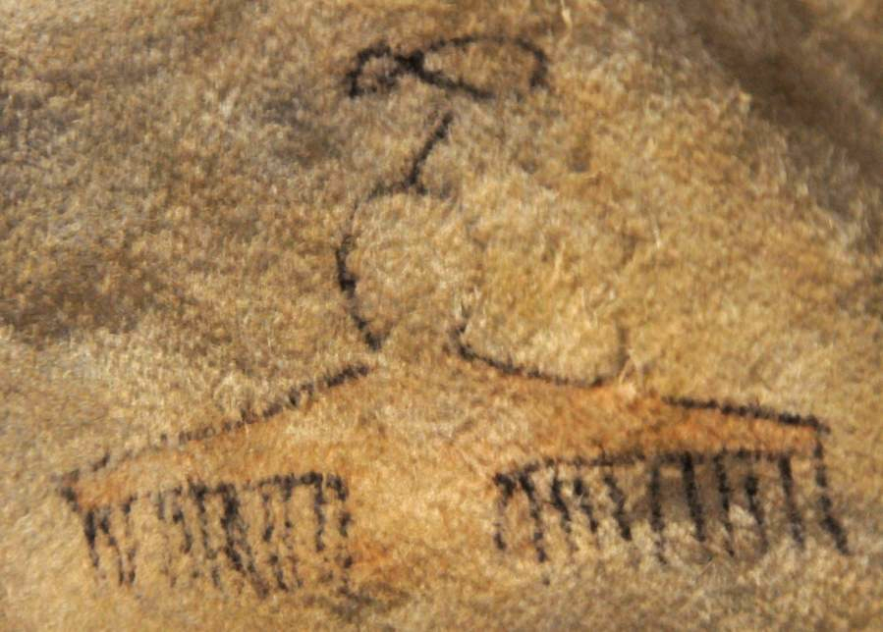

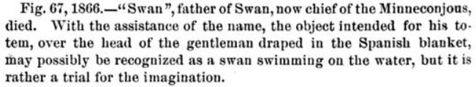

Note. Rather than Swan being draped with a Spanish blanket, it is Swan in his role of a shaman taking flight with draping wings of the swan.

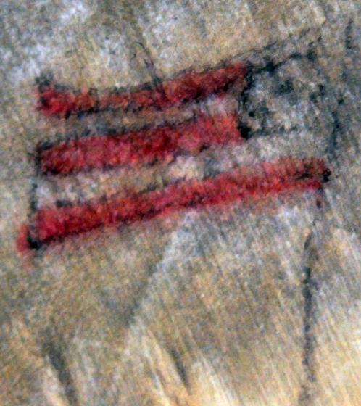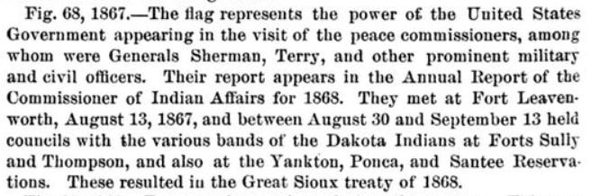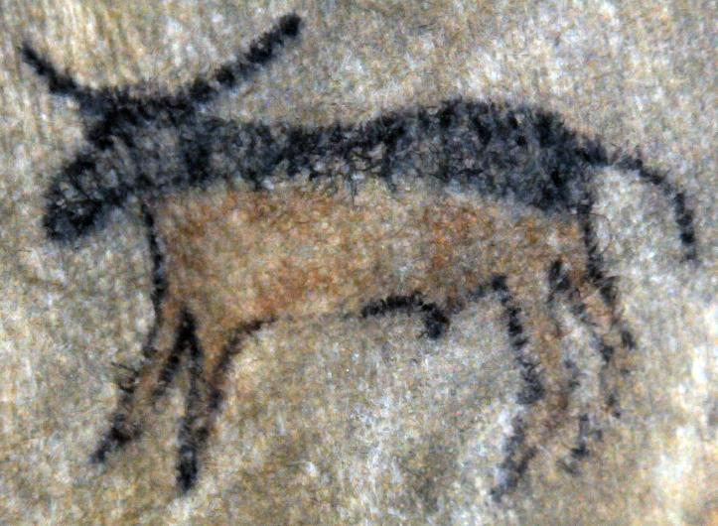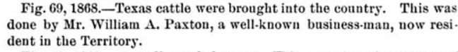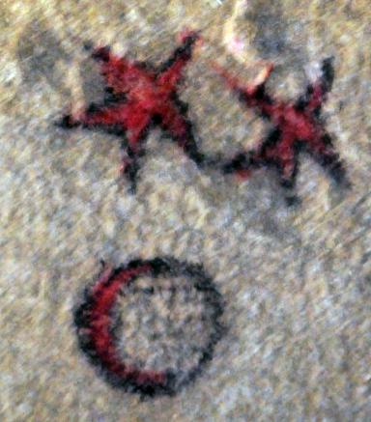

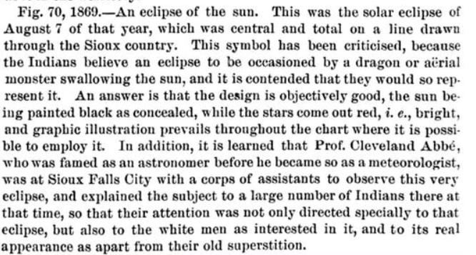

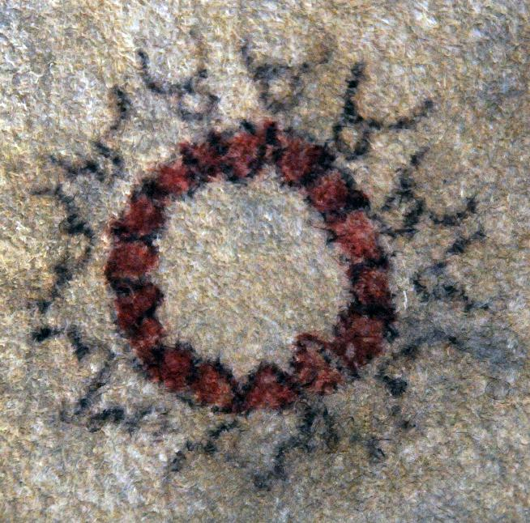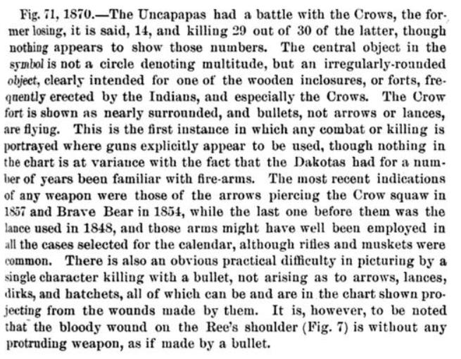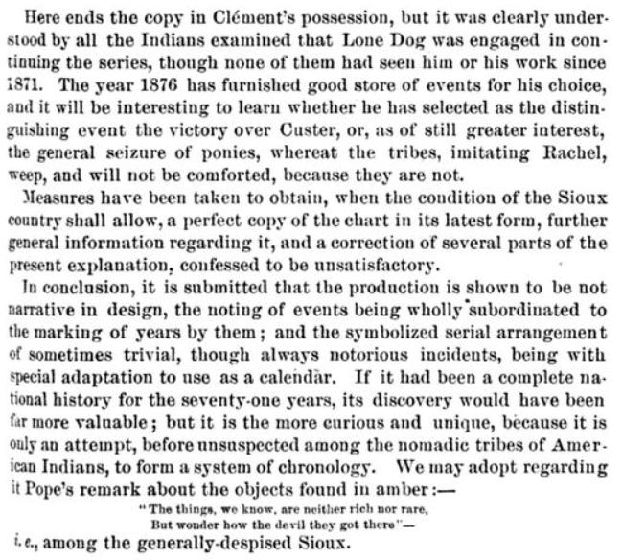

In the Atlantika Winter Count the years are continued according to the account of American Horse

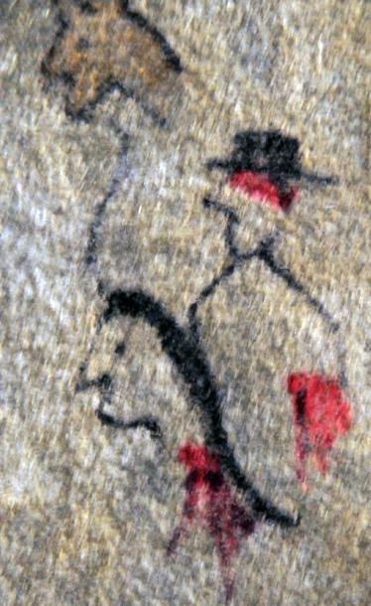

1871-1872

American Horse Winter Count: In 1869 John Richard, a white trader, had shot a white soldier at Fort Fetterman, Wyoming, and fled north, joining Red Cloud (Corbusier 1886: 145). Then in the Spring of 1872 John Richard shot and killed an Oglala named Yellow Bear; Oglalas then killed Richard in retaliation. The signs in this year’s totem have Yellow Bear first (as the first killed), then Richard (as the second killed). Behind them both is Yellow Bear’s horse.

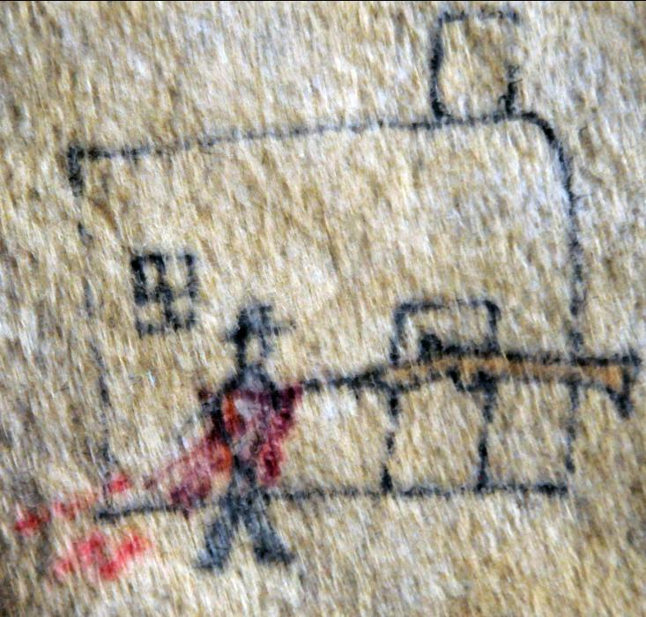

1873-1874

American Horse Winter Count: The Oglalas killed the Indian Agent’s Clerk inside the stockade of the Red Cloud Agency at Fort Robinson, Nebraska (Corbusier 1886:145).

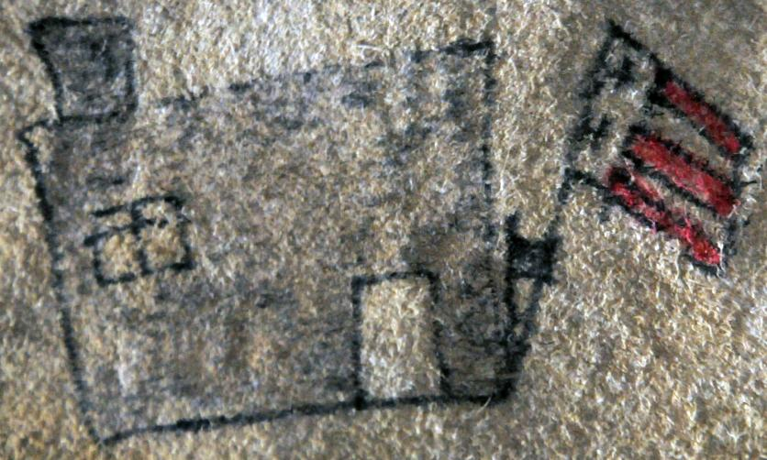

1874-1875

The Oglalas at the Red Cloud Agency, near Fort Robinson, Nebraska, cut to pieces with tomahawks the flag staff that their agent had erected because they did not wish to have the U. S. flag flying over their agency (Corbusier 1886:145).

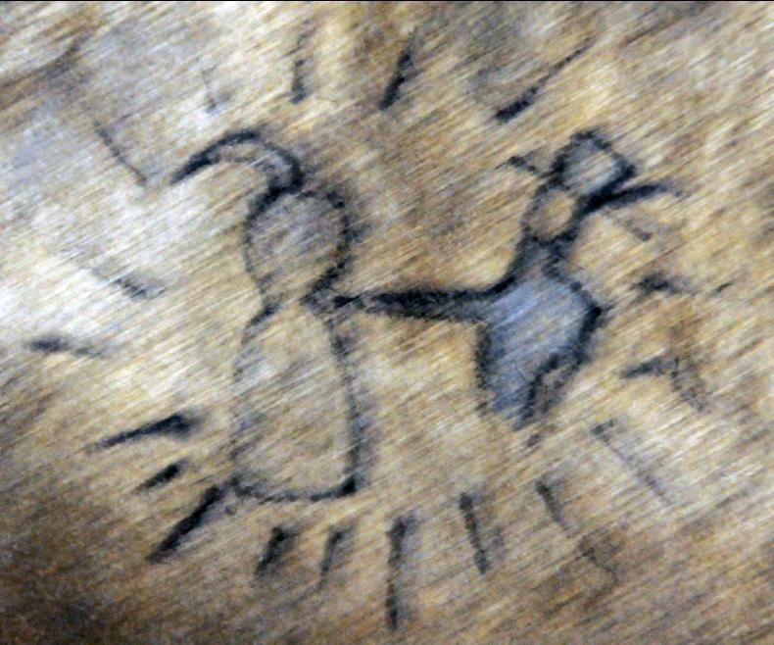

1875-1876

The Flame Winter Count: Council at Spotted Tail Agency (Mallery 1886:127). This year’s totem depicts the Spotted Tail Agent and the Lakota, One Horn, in council surrounded by people.

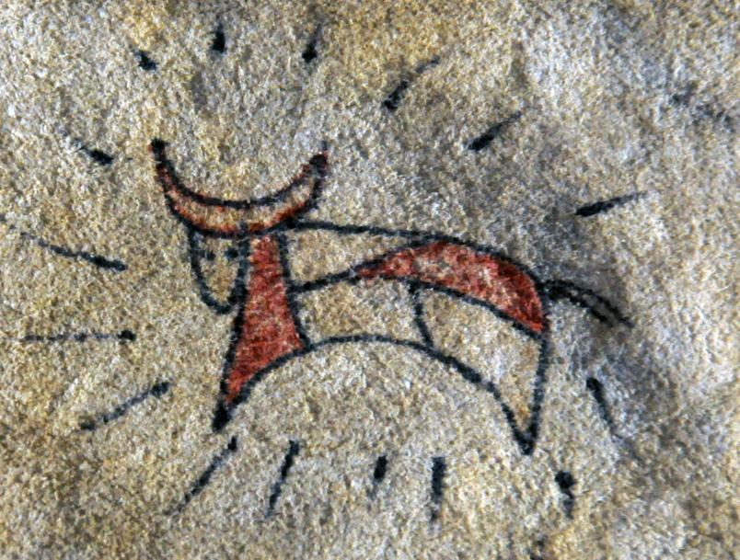1875-1876

At the 1875 Council at Spotted Tail Agency the first domestic cattle were issued to the Lakota (Corbusier 1886:145). This year’s totem reflects the curious fact that the Lakota called domestic cattle *pte gleska, “*spotted buffalo.” This year is only one in which there are two entries to identify its significance.

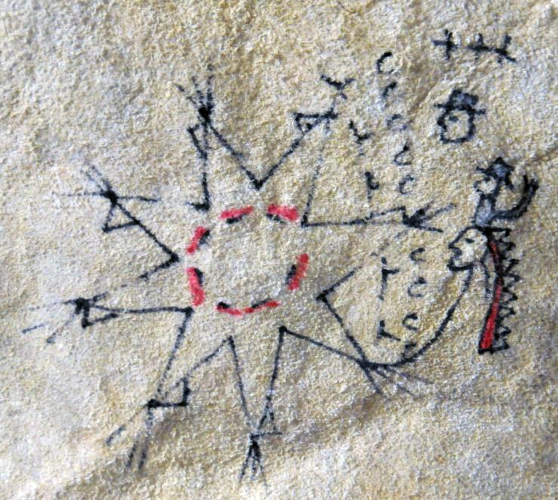

1876-1877

The Oglalas helped General Mackenzie to whip the Cheyennes. To the far right is Gen. Mackenzie holding up three fingers. He is placed on the head of the Dakota chief with a war bonnet because the Dakotas backed him in war. The three crosses at top refer to General Crook (pictured below) , who as major-general of volunteers or as brevet major-general in the Army was entitled to only two stars (Corbisier 1886:146). The Dakota Chief with the war bonnet is linked to the Cheyenne village to the left because he was first to enter the village in this skirmish. The red lines in a circle in the village represent the slain Cheyenne.

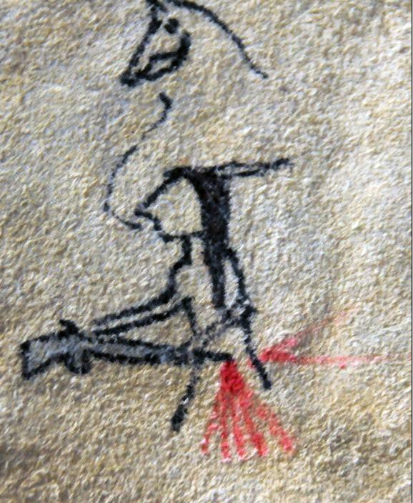

1877-1878

American Horse

Crazy Horse was killed. On Sept. 5, 1877, an unnamed soldier ran a bayonet into Crazy Horse when he was a prisoner in the guard house, at Fort Robinson, Nebraska (Corbusier 1886:146). The worthlessness of this officer is indicated by the fact that the bayoneted rifle pointing at Crazy Horse in unmanned.

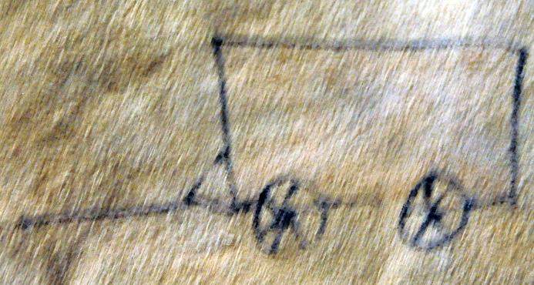

Atlantika Winter Count 1878-1879

American Horse Winter Count. Wagons were given to them. White Cow Killer calls this “Wagons –given –to-the-Dakota-winter” (Corbusier 1886:146).

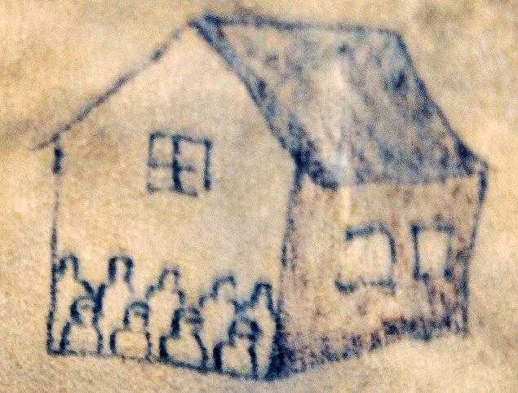

Atlantika Winter Count 1880-1881

Rosebud Winter Count: Sent boys and girls to school. This event is recorded for the previous year in the Winter Counts of Red Horse Owner and Wounded Bear (Greene and Thornton 2007:281).

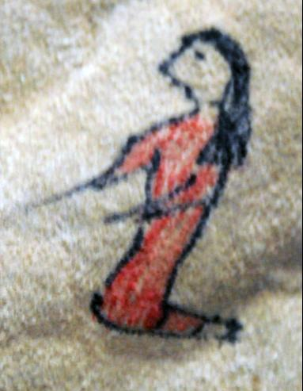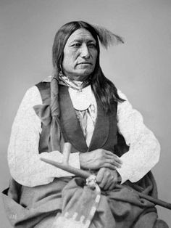

Atlantika Winter Count 1880-1881 (left); Sotted Tail (Lakota: **Siŋté Glešká)** (ca. 1823 - August 5, 1881) (right).

**Rosebud Winter Count transcript**: Chief Spotted Tail was a Brulé Lakota tribal chief. He was a great warrior in his youth, and participated in the Grattan massacre, the opening engagement of the First Sioux War, fought between the Lakota and the United States Army on August 19, 1854. However, had become convinced of the futility of opposing the white incursions into his homeland by settlers and miners using the Bozeman trail that had been opened up in 1863. He refused to participate with Red Cloud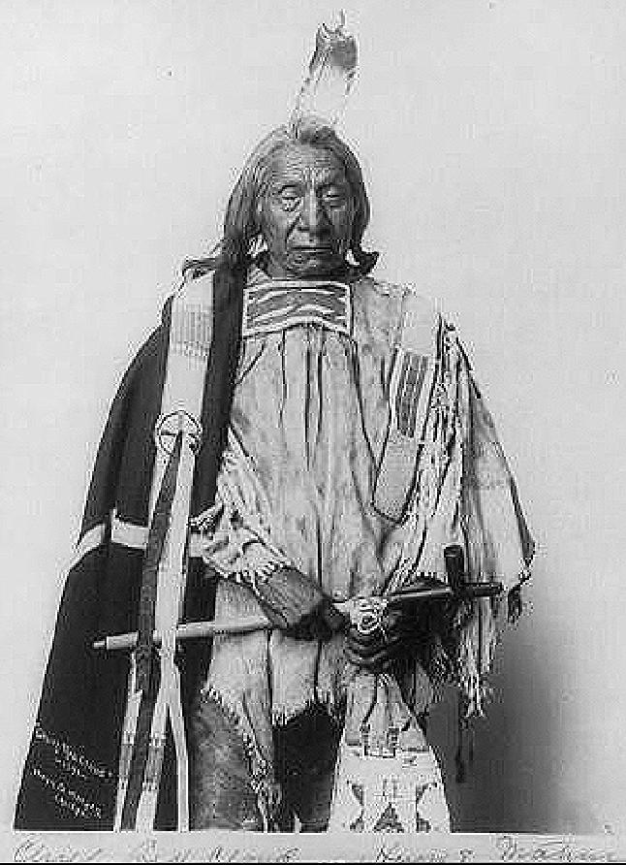 in organizing the Lakota, Northern Cheyenne, and Northern Arapaho to fight the United States cavalry in Wyoming and Montana territories from 1866 to 1868. Instead, he became a statesman, speaking for peace and defending the rights of his tribe (Hyde 1974).

In 1874 he negotiated mineral rights of the Black Hills which were sacred to the Lakota, and in 1875 he arranged for Crazy Horse, who was married to his sister, to peacefully surrender. When Red Cloud had fallen out of favor he became chief of the Brulé and Oglala tribes. This brought on hostile feuds among the tribes in which Spotted Tail was accused of advances toward Crow Dog’s wife. Crow Dog shot and killed Chief Spotted Tail on the Rosebud Indian Reservation as he was returning home with his wife from delivering a load of wood. Crow Dog was arrested and tried in a territorial court in Deadwood, Dakota Territory, and found guilty of murder and sentenced to hang. However, the Deadwood Court had no jurisdiction in a case of one Indian killing another on reservation lands, so Crow Dog was released and returned to the Rosebud (hyde 1979:332-5). This murder has been regarded as a political plot by more radical factions to unseat him as Brulé chief.

Red Cloud (Lakota: Mahpíya Lúta) (1822 – December 10, 1909)

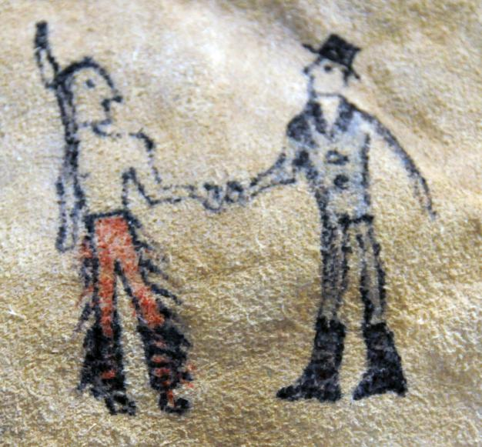

Atlantika Winter Count 1883-1884

U.S. Army makes treaty with Lakota. This is an unidentified event in corresponding Winter Counts at the Smithsonian.

REFERENCES

Allen, Anne Beiser. 2009. A Scandal in Niobrara: The Controversial Career of Rev Samuel D Hinman, Nebraska History

90: 114-129.

Anderson, Gary Clayton and Alan Roland Woolworth. 2014. *Through Dakota Eyes*. St. Paul: Minnesota Historical Society.)

Burke, Christina E. “Collecting Lakota Histories: Winter Count Pictographs and Texts in the National Anthropological Archives.” *American Indian Art* 26:1 (2000): 82-89, 102-03.

Carkeek-Cheney, Roberta. *Sioux Winter Count: A 131-Year Calendar of Events*, Naturegraph Publishers, Inc., Happy Camp, CA, 1998.

# Carson, James. 2015. *Against the Grain: Colonel Henry M. Lazelle and the U.S. Army.* Denton, Texas: University of North Texas Press.

Corbusier, William H. 1886. The Corbusier Winter Counts. In *Fourth Annual Report if the Bureau of American Ethnology*, 1882-1883. pp. 127-147. Washington: Smithsonian Institution.

DeMallie, Raymond J., ed. Handbook of North American Indians, Vol. 13 Plains. Washington, DC: Smithsonian

Institution, 2001.

Greene, Candace S. and Russell Thornton. 2007. *The Year the stars fell: Lakota Winter Counts at the Smithsonian*. Washington: Smithsonian.

Horse Capture, Geoge, P., Vitart, Anne, Waldberg, Michel, West, Richard W., Jr. 1993. *Robes of Splendor: Native North American Painted Buffalo Hides,* The New Press: New York.

Hyde, George E. 1974. Spotted Tail's Folk: A History of the Brulé Sioux. Tulsa: University of Oklahoma Press.

Mallery, Garrick. 1877. A Calendar of the Dakota Nation. U. S. Geological and Geographical Survey Bulletin 3(1):3-15.

Mallery, Garrick 1886. Pictographs of the North American Indians: A Preliminary Paper. In Fourth Annual Report of the Bureau of American Ethnology, 1882-1883. Pp. 1-256. Washington: Smithsonian Institution.

National Anthropological Archives. 1877. MS 2372, Box 12, Folder 5.

Penticoff , Kelly. 2011. “Bazille Jacque Marie "Basil" Clement - Claymore, Sr.” Accessed 31 Mar 2016 from http://www.findagrave.com/cgi-bin/fg.cgi?page=gr&GRid=71353538

Smith, George Martin, ed. 1915. South Dakota its history and its people. In GeorgeKingsbury, , *History of Dakota Territory*. Chicago: S. J. Clark Publishing Co.